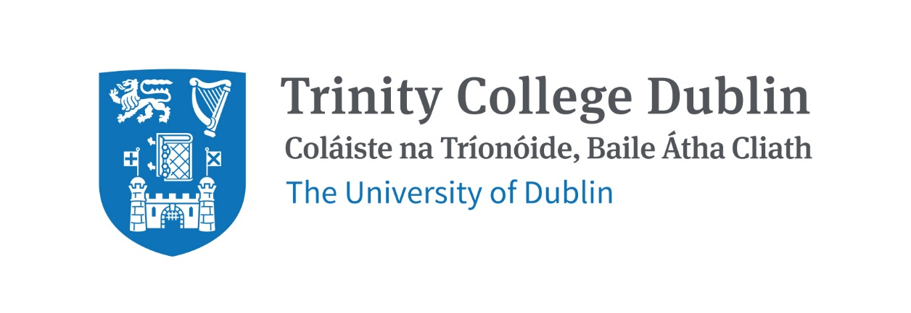

Trinity Business School

ECONOMICS FOR MANAGEMENT

2026/27

MODULE CODE: BUU11520

MODULE NAME: Economics For Management

ECTS: 10

Lecturer: tbc
Office Hours: tbc

Teaching Assistant(s): tbc
Office Hours: tbc

Module not available to incoming exchange students

MODULE DESCRIPTION

This full academic year module focuses on the principles of economics and provides a foundation for more advanced modules in economics/social sciences-related disciples available in later years. The module assumes no previous knowledge of economics.

The first part of the module covers microeconomics, which is concerned with the allocation of scarce resources between competing uses at the disaggregated level of individuals, households and firms. The central issue concerns market equilibrium and the roles of the (appropriately regulated) market place and of the government in allocating resources. Efficiency, equity and administrative simplicity/plausibility provide the underlying metrics of success (or otherwise).

The second part of the module covers macroeconomics, which is concerned with economy-wide aggregates such as the overall scale of, and growth in, economic activity and productivity, the rate of inflation and the levels of employment/unemployment. The central issue concerns the role of the government in tackling macroeconomic challenges such as reducing unemployment, mainstaining price stability and promoting growth and equity as well as environmental sustainability and (unpaid) care.

LEARNING AND TEACHING APPROACH

The module will consist formally of two weekly lecture and a fortnightly tutorial. Very active participation and involvement is expected within that context and more generally, e.g. assignments, readings, discussions/debates. Participants will receive feedback on their two assignments, which should be of particular use in preparing for the final exam.

MODULE-LEVEL LEARNING OUTCOMES

- Explain and apply basic economic terminology;
- Identify the key outcomes of interest for economic policy makers and the primary policy tools used to pursue the associated goals;
- Explore economic, social and political events through the lens of economics;
- Evaluate public policy making; and,
- Articulate economic reasoning and results to others.

RELATION TO DEGREE

WORKLOAD

Content | Indicative Number of Hours
Lecturing hours (and classes/tutorials) | 50
Preparation for lectures (and classes/tutorials) | 75
Individual assignments | 75
Group assignment
Reading of assigned materials and active reflection on lecture and course content and linkage to personal experiences | 60
Final exam preparation | 20 (assuming previous investments)
Total | 280

TEXTBOOKS AND REQUIRED RESOURCES

Required core course textbook: Gregory Mankiw, Principles of Economics, any recent edition, is recommended.

General Supplemental Readings: See Blackboard for many readings and media links which will be updated on a regular basis.

Also see http://www.core-econ.org. CORE is an open-access, interactive ebook-based course for anyone interested in learning about the economy and economics.

Student preparation for the module:

COURSE COMMUNICATION: See Blackboard Ultra and tcd email.

Please note that all module related email communication must be sent from your official TCD email address.

ASSESSMENT

There will be regular problems/issues to be addressed and submitted via Blackboard before the associated regular class/tutorial. There will be approximately 5 such homeworks/classes each term. These questions will prepare you for the type of questions asked in the final exam which will be worth 50 per cent of your overall grade/mark. It is expected that this final exam (administered by College) will be 90 minutes Face-to-Face in late April/early May 2027.

There will be a MT assignment (worth 25 per cent of your overall grade) due to be submitted by the end of teaching term, i.e. Friday 4th December 2026 (details to be confirmed). A maximum extension of two weeks in this deadline is possible, via the submission of a medical certification or a request for an excused absence from your College Tutor.

There will be a HT assignment (worth 25 per cent of your overall gared) due to be submitted by the middle of reading/study week, i.e. Wednesday 3rd March 2027 (details to be confirmed). Again, a maximum extension of two weeks in this deadline is possible, via the submission of a medical certification or a request for an excused absence from your College Tutor.

For students who do pass the module and hence require a supplemental exam (again, Face-to-Face), the module final grade will be based 100% on the supplemental exam.

MODULE SCHEDULE

Term
Session | Date & Venue | Lecture & readings
MT Sessions | Lecture times – tbc  Tutorial time - tbc | Microeconomics (details to be confirmed)  Economic Principles  Demand, Supply, Equilibrium  Efficiency and Welfare  Equity/Fairness  Price Regulations (e.g. rent control and min wage regulations)  Consumers and Producers  Perfect Competition and Monopoly  Externalties and Public Goods
HT Sessions | Lecture times - tbc  Tutorial time - tbc | Macroeconomics (details to be confirmed)  Measuring Output and Economic Growth/Efficiency  Externalities and Environmental Sustainability  Productivity  Measuring Prices/Inflation  Equity/Fairness  Fiscal Policy (T and G)  Monetary Policy  Competition Policy  Regulation

Biographical Note:

