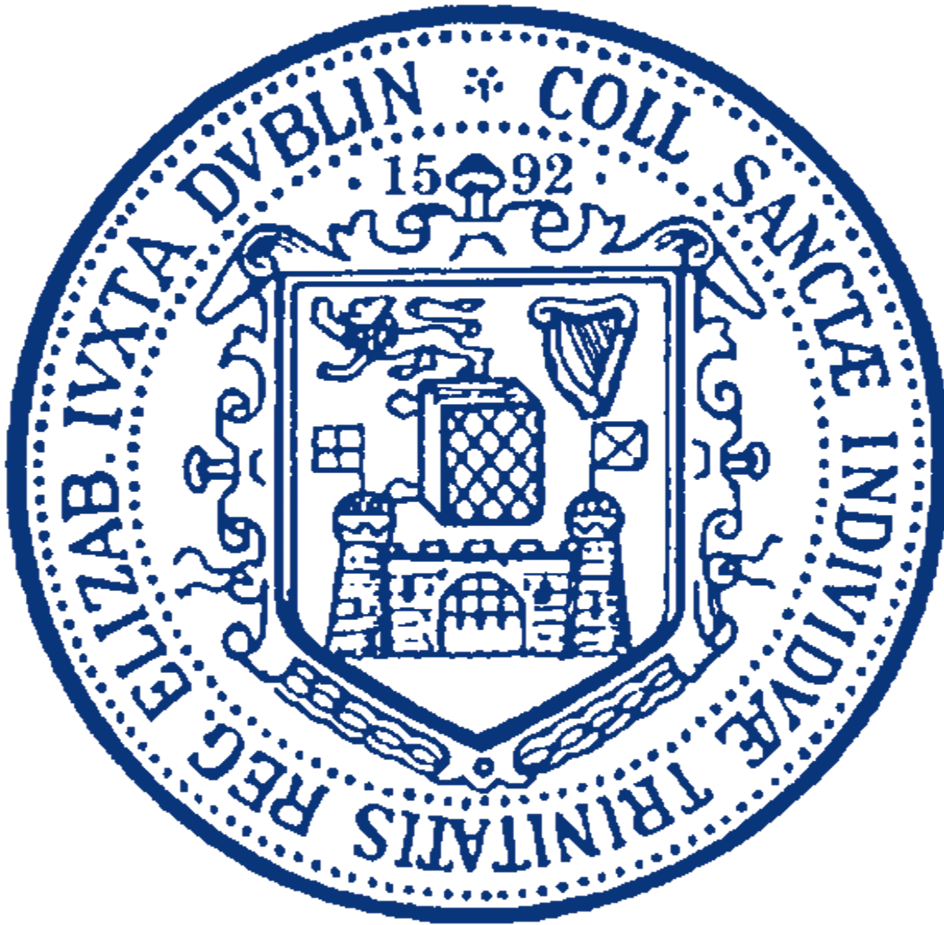

EMPLOYMENT LAW UPDATE

SATURDAY, 17 NOVEMBER 2007

ABOUT THE CONFERENCE:

The Law School of Trinity College Dublin, in conjunction with the firm of Arthur Cox, is holding a conference on Saturday 17 November 2007, entitled Employment Law Update. The team of speakers, from Arthur Cox, are experts in their areas. The conference will be of relevance, not only to legal practitioners, but to all involved in human resources recruitment and dismissal. The law in this area has become complex in recent years and it is a challenge to keep up with all the recent legislative and judicial developments.

The conference offers an excellent opportunity to review the legal changes with acknowledged authorities in employment law. There will be an interactive session which will enable the exchange of information and the discussion of key issues.

The conference will be held in the Walton Theatre, Arts Building, Trinity College Dublin.

TOPICS TO BE DISCUSSED:

The Employees (Provision of Information and Consultation) Act 2006
Stress, Bullying and Harassment
Protection of Employees (Fixed Term Work) Act 2003
Changing Concepts in the Contract of Employment, Discipline and Dismissal
Issues Relating to Discipline and Dismissal: Recent Developments

LECTURERS:

The team of lecturers consist of seven members of Arthur Cox:


Cian Beecher specialises in all areas of employment and industrial relations law including advising employers on the employment law aspects of inward investment and commercial transactions and all matters arising out of the employer-employee relationship (such as the management of ongoing employee issues, termination of employment and the implementation of appropriate HR policies and procedures). Cian also represents employers in contentious employment and industrial relations disputes. Prior to joining Arthur Cox, Cian worked as an in-house legal adviser to a large multinational corporation.


Seamus Given, Partner, Arthur Cox, specialises in employment and industrial relations law and also advises educational institutions, hospitals and other public bodies on issues arising in the context of their relationships with government, staff, students and other interested parties. He was awarded the degrees of BCL and LLM by University College Cork and the Diploma in European Law by University College Dublin.









Kevin Langford, Partner, Arthur Cox, is a member of the Employment Law Group and specialises in all aspects of employment and industrial relations law. He joined Arthur Cox in 2001, having previously been in-house legal advisor with the Irish Business and Employers Confederation.

Elaine Mettler specialises in employment, equality, industrial relations and immigration law. She advises a broad range of clients to include public bodies, private and public limited companies, charities and those in the educational and health sector, on all matters arising from the employment relationship and employer/trade union relationship. Elaine’s advisory work extends to the review and drafting of a variety of employment documents to include employment contracts, staff handbooks and employment policies.

Dr Mary Redmond, Consultant, Arthur Cox, has extensive experience of employment law. She provides a full range of legal services to employers and industrial relations and was a member of the Labour Relations Commission during two consecutive terms. She is the author of Dismissal Law (1999) and an Honorary Fellow of Christ’s College, Cambridge. She is a Council Member of the Institute of Directors UK.

Barry Reynolds qualified onto the Roll of Solicitors of Ireland in 2004. He has an LLB from Trinity College Dublin. Barry joins us from A & L Goodbody where he did his traineeship and then joined its employment law unit advising on all aspects of Irish employment law and related issues. He will be working on our employment law team and will also be seconded to AIB.

Gill Woods trained as a solicitor with Arthur Cox and following qualification commenced practice in the Employment Law Group of Arthur Cox. Gill provides a full range of legal services to employers on all matters arising in the course of the employer/employee relationship and at termination of employment. She advises employers on employment law aspects of commercial transactions, individual and collective issues, termination of employment, policy and procedure framework and on a wide range of employment related matters arising in the course of employment.

RESERVATIONS AND FEES:

FEES* € 150 for 1; €270 for 2; €385 for 3; €480 for 4 and €565 for 5.

To reserve your place please complete the booking form on the back page and return it to the address below. Alternatively, links to the conference details and booking forms can be found on http://www.tcd.ie/Law/Events

* fees are inclusive of tea/coffee breaks and copies of the presentation

Please make all cheques payable to TCD No. 1 Account
Programme :

9:00 - 9:25 | Registration
9:30  Dr Mary Redmond | Conference Overview
9:45  Seamus Given | Fixed-Term Contracts: Recent Developments in the Law
10:15  Elaine Mettler | How to Deal with Bullying, Harassment and Occupational Stress  in the Workplace
11:00 | Tea/Coffee Break
11:20  Cian Beecher and  Barry Reynolds | Managing the Recruitment of International Workers
12:00  Kevin Langford and  Gill Woods | Case Study on Disciplinary Procedures
12:50 | Conference Ends

BOOKING FORM:

Please complete in block letters:
Name(s):

Company/
Organisation:

Address:

Tel: Fax:

Email:

Cheque enclosed in the sum of*:

