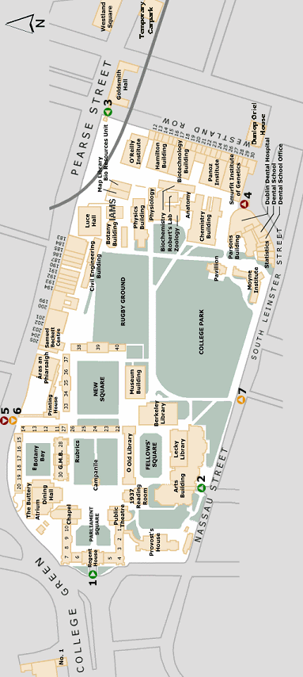

Cumberland Street South

Arts Building

Front Gate

Car Park

Nassau Street Entrance

