
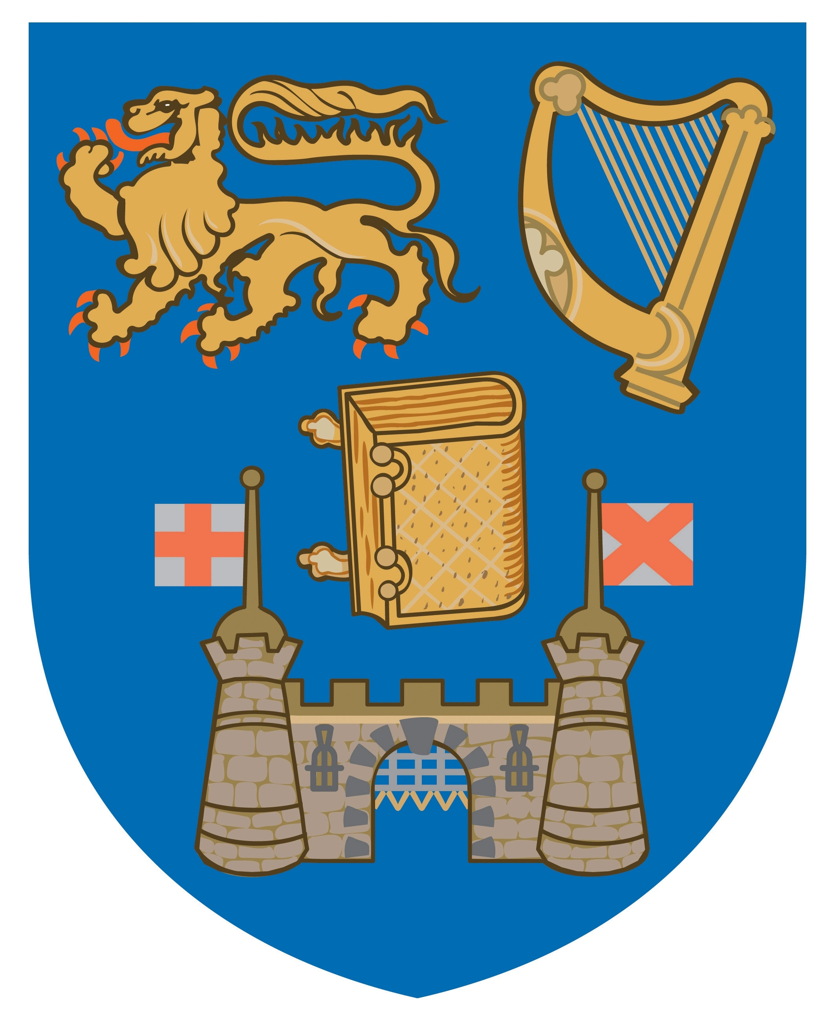

CONFERENCE BOOKING FORM
I would like to attend the following conference(s):

Medical Negligence 2010: Latest Developments For Practitioners
Saturday, 20 November 2010

Defamation and Privacy Law
Thursday, 2 December 2010

Please complete in block letters:

Name(s):

Company/
Organisation:

Address:

Tel: Fax:

Email:

Cheque enclosed in the sum of:

ALL CHEQUES SHOULD BE MADE PAYABLE TO TCD NO. 1 ACCOUNT
Please see the conference website for details on payments via PayPal

Return to:
CPD Conference Programmes, School of Law, House 39, Trinity College, Dublin 2

