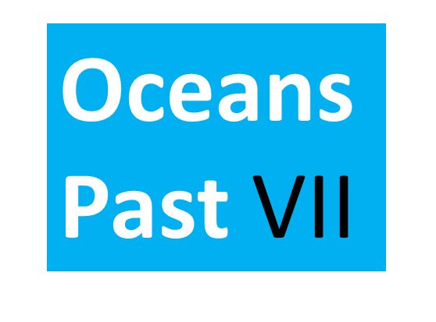
INTERNATIONAL CONFERENCE
– Call for papers –
Tracing human interactions with marine ecosystems through deep time: implications for policy and management
Alfred Wegener Institute Helmholtz Centre for Polar and Marine Research (AWI) &
the German Maritime Museum, Bremerhaven, Germany: 22th to 26th October 2018
____________________________________________________________________________________________________________________________________________________
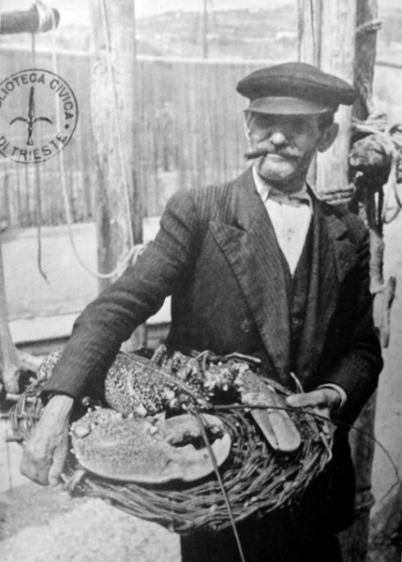
Rationale: Knowing the past is vital for developing a vision of the future. The oceans and inshore seascapes of the world are rapidly changing, and understanding the human and marine ecosystem forces, trajectories and responses – sometimes over centuries or millennia – is vital for their informed management. Understanding, quantifying, and predicting humanities interactions with the world’s coastal seas and oceans requires examination of our practices of consumption, transportation, extraction and pollution, as well as our values and governance systems. The conference aims to bring together the vast knowledge pool of two decades of marine historical ecology and environmental history to inform the policies of the Anthropocene.
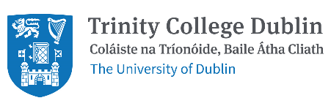
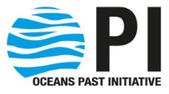
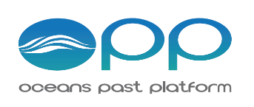
Invitation: The conference welcomes researchers, practitioners, policy-makers and students of all disciplines under the unifying view of our oceans as networks of social-ecological or coupled human-nature systems. If you have an interest in the history of human interactions with life in the ocean and implications for policy and management, this is the 2018 conference you must attend.
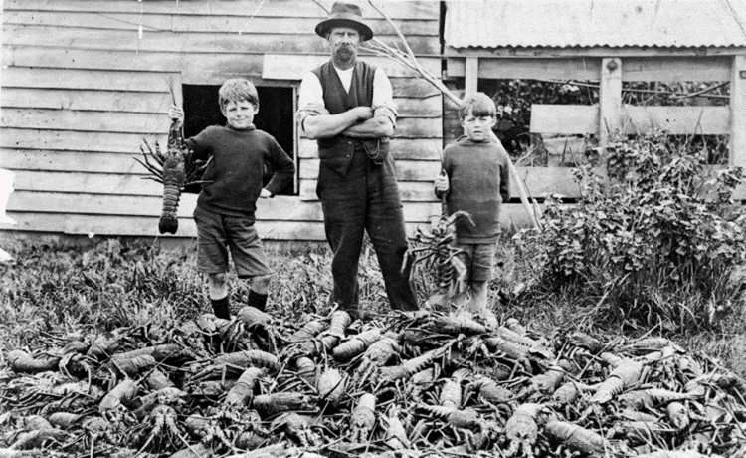
Deadline for paper submission: 31 March 2018
How to submit an abstract: Please provide the following information (in .doc file) to info@oceanspast.org
- Title of presentation
- Full name(s) of all author(s)
- Affiliation (of all authors; institute, town and country)
- Abstract (max 200 words)
- Preferred session (please select one from the list below):
- Oceans prior to contemporary exploitation
- Drivers of environmental use and change across historical time frames
- The significance of marine resources for human societies over time
- Factors that have encouraged societies to exploit or leave the oceans
- Development of indictors
- Implications of past and present human ocean activities for coastal and marine policy development
- Preferred presentation type (oral or poster)
Call for special sessions, mini-symposia or exhibitions: The conference organisers offer you the opportunity to suggest or organise a special session, mini-symposium, or exhibition of relevant artefacts, artwork, or documentary film screenings during the conference within the broad theme of the history of human impacts with life in the ocean. Send your suggestions to the convenors below.
Contacts: Conference convenors: Alison MacDiarmid a.macdiarmid@niwa.co.nz and Poul Holm holmp@tdc.ie
Chair local organising committee: Gesche Krause Gesche.Krause@awi.de
Chair of the conference Scientific Steering Committee: Henn Ojaveer henn.ojaveer@ut.ee
Conference website: http://oceanspast.org/oceanspastvii.html

