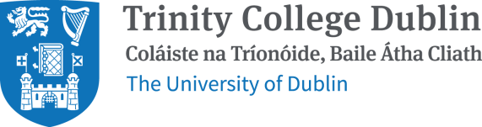
Junior Sophister Essay Submission Form
Student Number:……………………………………………………………………………………. PLEASE TICK ONE OF THE FOLLOWING:
SINGLE HONOR
TSM
HPS
EUROPEAN STUDIES
ANCIENT AND MEDIEVAL HISTORY & CULTURE
ONE YEAR/TERM VISITING
ERASMUS

Module Code:…………………………………………………………………………………………… Module Title:…………………………………………………………………………………………….
………………………………………………………………………………………………………………….
Module Lecturer/Dissertation Supervisor:.……………………………………………... PLEASE TICK ONE OF THE FOLLOWING:
MICHAELMAS TERM
LIST I MICHAELMAS TERM ESSAY
LIST II ONE‐TERM MODULE – MICHAELMAS TERM ESSAY
LIST II YEAR‐LONG MODULE – MICHAELMAS TERM ESSAY
EXAMINATION ESSAY – ERASMUS & VISITING STUDENTS ONLY
HILARY TERM
DISSERTION PROPOSAL
LIST I HILARY TERM ESSAY
LIST II ONE‐TERM MODULE – HILARY TERM ESSAY
LIST II YEAR‐LONG MODULE – HILARY TERM ESSAY
EXAMINATION ESSAY – ERASMUS & VISITING STUDENTS ONLY

PLEASE TICK TO CONFIRM:
I have also submitted an electronic copy to TURNITIN

