Faculty of Health Sciences Office

How-to-guide for completing the
TCD Covid Induction Module on

Log into Blackboard: Blackboard Learn (to find this on your browser, type ‘mymodule.tcd.ie’ in the address bar)

You will see a screen similar to the one below. Type ‘Covid’ into the module search box, and press go.

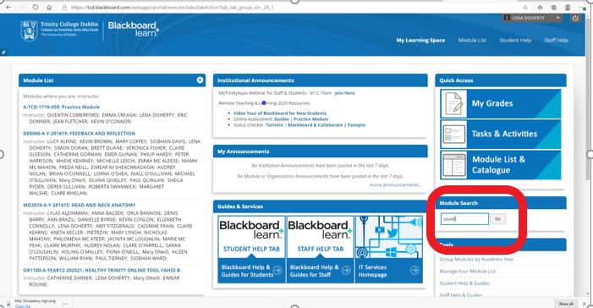

PTO

Among the list of options, you should see ‘Covid-Induction’ a module by Katharine Murrary, College Safety Officer. Click the box beside this module, and click on the ‘enrol’ option (see screenshot below). On the following screen, press ‘submit’ to proceed.
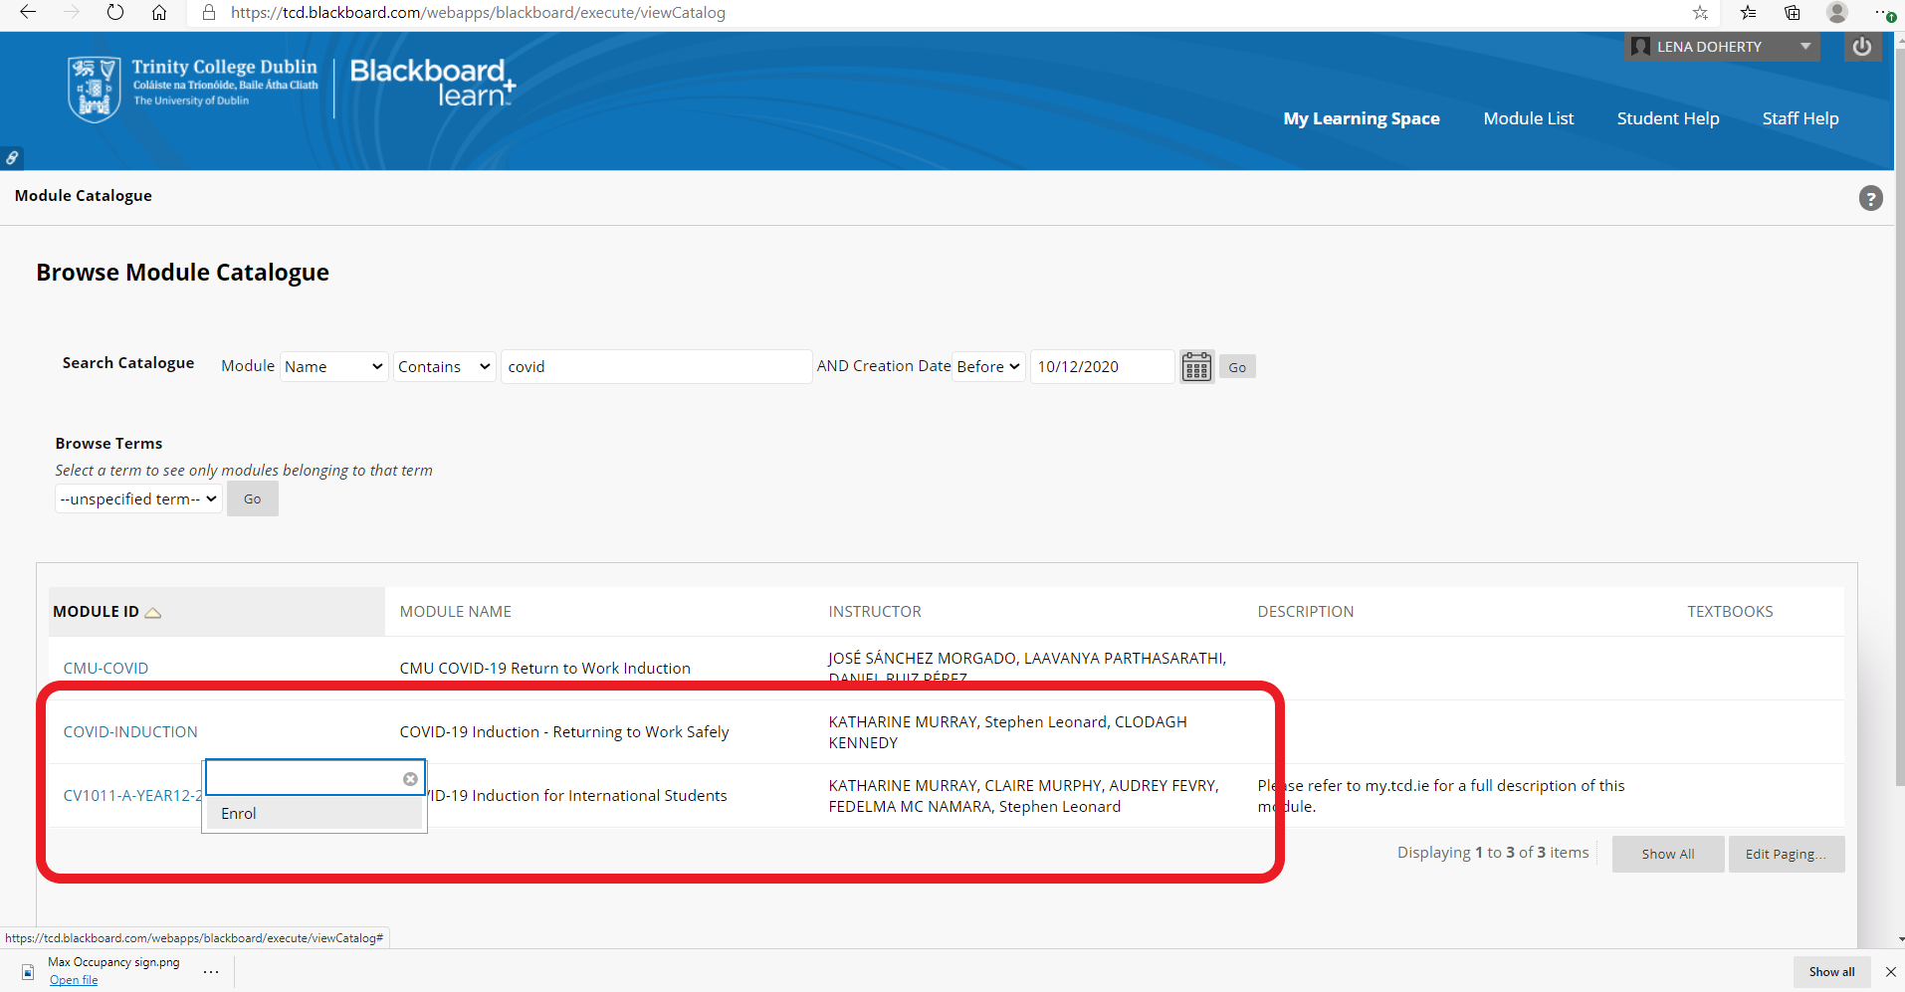

You will now be in the module – you can click on the different sections (intro / video / staff details) on the left side of the screen (note the video is approx. 15 minutes long)

