Application Form
International Byzantine Greek Summer School
Online through Trinity College Dublin, July–August 2024
please submit to ibgss.tcd@gmail.com
1. |  | Surname
2. |  | Forenames
3. |  | Title (Mr, Mrs, Ms, Dr etc.)
4. |  | Nationality
5. |  | Date of Birth (day, month, year)
6. |  | Occupation
7. |  | Home address
8. |  | Academic or business address, if applicable (students: enter your address in term time)
9. |  | Email address
10. |  | Telephone numbers: |  |  |  | Mobile:
 |  |  |  |  |  | Work:
 |  |  |  |  |  | Home:
For students only:
11. |  | Name and location of school, college or university
12. |  | Degree or other qualification for which you are studying, and the subject area.
13. |  | Level of study (pre-university, undergraduate, taught postgraduate, research postgraduate) & year of study
For all applicants:
Please mark one box only.
14. |  | In which time zone will you participate in this course? |  |  |  |  | (a) | The time zone of my home address
 |  |  |  |  |  |  | (b) | The time zone of my college/university/school
 |  |  |  |  |  |  | (c) | A different time zone, namely:
15. |  | Course(s) for which you are applying |  |  |  |  | (a) | Level 1 only  course fee €350
 |  |  |  |  |  |  | (b) | Level 1 and Level 2/2.5  course fee €700
 |  |  |  |  |  |  | (c) | Level 2/2.5 only  course fee €350
 |  |  |  |  |  |  | (d) | Level 3 only  course fee €350
16. |  | English language proficiency  If you are not a native speaker of English, please indicate your level of proficiency using the categories of the Common European Framework of Reference for Language Learning:  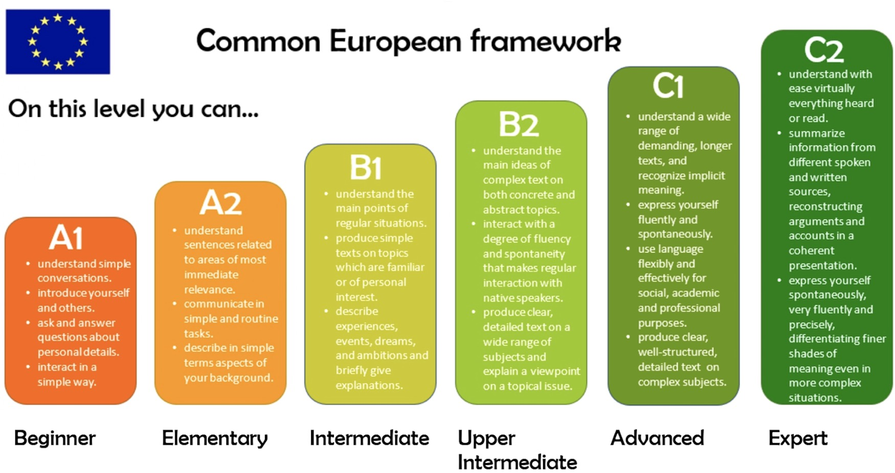
Speaking
Listening
Reading
Writing
17. |  | Funding
Are you able to fully cover course fee for this Summer School yourself?
Please type YES or NO. If your answer is NO, please follow the instructions for bursary applications in the Guide for Applicants.
18. |  | Personal information  Please complete this section if you have a medical condition, disability or other personal information you want us to be aware of.
In Questions 19-22, please provide as much detail as possible.
If needed, the boxes will expand automatically as you type.
19. |  | Give details of your current knowledge of Greek (if any), including Classical, New Testament and Modern Greek, and list courses attended (including previous visits to the Byzantine Greek Summer School in Belfast, Birmingham or Dublin).
20. | What are your reasons for wanting to participate in the Byzantine Greek Summer School?
21. | How do you intend to continue the study of Byzantine, New Testament or Classical Greek after the Summer School?
22. | For Level 3 (Advanced Reading) applicants only  Please give details of one text that you would like to study as part of Level 3. Give as much detail as possible, including editions, page numbers, book/section, chapter references. You may be asked to provide the organizers with a pdf-copy of the text.

[End of application form]

