Writing Effective Multiple Choice Questions

Introduction
Multiple Choice Questions (MCQs) are a useful assessment tool and can be an effective and efficient way to assess learning outcomes. They are easy to administer, assess, and integrate into online teaching practice. MCQs are best combined with other forms of assessment (e.g. are not for sole use). Assessing higher-order thinking skills through MCQs requires significant planning. This document aims to describe guidelines for writing and designing MCQs effectively.

What are Multiple Choice Questions?
One of the principles of MCQs is to enable the demonstration of acquired learning outcomes, through testing the acquisition and recall of facts. As an assessment tool MCQs are typically associated with objectivity and reliability. MCQs can be used for summative or formative assessment purposes and can quickly provide feedback to students. The challenge when generating MCQs is to move beyond focusing on knowledge, concepts and processes to promoting and assessing more complex and abstract or ‘higher-order’ thinking.

Implementation Challenges  - MCQ format can encourage students to guess the correct answer or enable them to arrive at the correct answer for the wrong reason.  - Does not provide opportunities to access ‘process’.  - If designed poorly, MCQs can:  - Assess recall (surface learning) rather than complex learning (deep concepts).  - Limit the learnings that a student can show/demonstrate.  - Prevent students from seeing structural relationships between concepts.  - Be time-consuming for team and individuals to construct appropriately.  - Place a heavy duty of responsibility on question setter. | Benefits to Integrating MCQs into Practice  - Objectivity—providing specific answers at the outset of the assessment reduces risk of subjective impact of marking.  - Reliability—enabling consistent measuring of learning outcomes.  - Validity—enabling effective measuring of learning outcomes.  - Enhanced breadth of content coverage as part of an integrated approach to assessment practice.  - Higher cognitive reasoning (if well written).  - Speed of return of marking increased and quicker statistical analysis of student performance.  - Administrative management can be made easier through technology-enhanced learning.

What should I consider when designing MCQs?
- Establish what are you trying to assess, and why.
- Identify the context and purpose of the question.
- Establish which mode of MCQ you are using:
  - True/false (e.g. select one answer).
  - Odd one out (e.g. find patterns/relationships).
  - Best-answer (e.g. more complex, testing critical thinking).
  - Multiple-response (e.g. showing linking relationships by selecting a number of correct answers).
  - Case study presenting material for follow-up MCQs (e.g. demonstrating how to apply knowledge/concepts to answer a scenario).
  - Incomplete scenario (e.g. fill the gap using multiple-choice answers).
  - Problem/solution evaluation (e.g. judge/evaluate appropriacy of answer provided).
  - MCQs interpreting a graphic (e.g. labelling a diagram, identifying an artist).
Note: Choice of MCQ mode should also take into account inclusion principles.

- Take particular care with verb choice in the stem and pay particular attention to verb choice and the quality of the distractors (see below).

Stems, Distractors and Key:
MCQs consist of: a stem (identifies the question or problem), the distractors (possible/plausible answers) and a key (the correct/best answer[s] to the question).

The stem: should provide all relevant material that a student requires to answer the question. Good stems have simple and direct vocabulary that are designed around a central idea. To ensure clarity:
- Use student-friendly language. Include an introductory statement if necessary, to provide context. Avoid negative stems.
- Include all the information in the stem required for one question.
- Ensure multiple questions do not feature in one stem to reduce likelihood of confusion.
- Be grammatically consistent, ensure clear phrasing and limit use of jargon.
- Avoid use of examples which may be unfamiliar to other cultures e.g. small Irish brand names.
- Limit ambiguity.

The distractors: should be plausible to reduce the likelihood of a student guessing the answer. To ensure clarity:
- Construct distractors that are comparable in length, complexity, grammar and form.
- Make sure there are limited numbers of alternatives (e.g. 3 to 5 per question).
- Avoid trick/opinion-based distractors.
- Consider presentation order of distractors for accessibility purposes.
Layout:
Layout is also important. Consider sequencing and readability from a student perspective—there should be consistency across a set of MCQs so that a student can readily distinguish between the stem and the distractors. It may also be worth ensuring that all keys are randomised across a set of MCQs.

Factors contributing to effective MCQ design to align with learning outcomes:
With careful planning, MCQs can be used to assess higher-order thinking skills as well as to assess recall. Effectively using MCQs to assess higher-order thinking requires a disciplined evidence-based approach. Higher-order thinking, drawing on the principles of Bloom’s Taxonomy, requires a student to evaluate or justify an answer. Verb choice in the question stem is indicative of the complexity of the cognitive ask of the student.

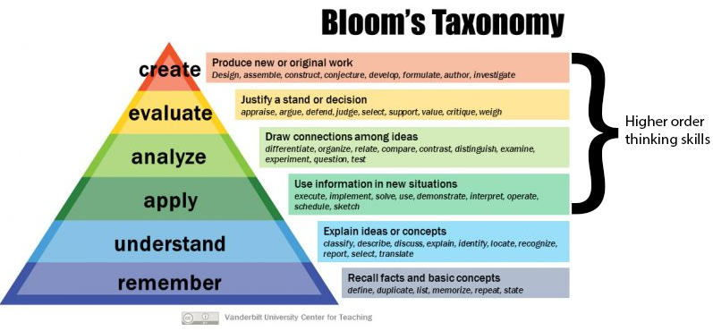

Figure 1. Bloom’s Taxonomy. From Vanderbilt University Center for Teaching (https://commons.wikimedia.org/wiki/File:Blooms-Taxonomy-650x366.jpg), added labels by Academic Practice, https://creativecommons.org/licenses/by-sa/4.0/legalcode.

Practical Strategies for incorporating higher order thinking:
When designing MCQs that enable students to demonstrate higher-order thinking:
- Ensure distractors are plausible (e.g. distractors superficially similar to the key require a student to demonstrate a high level of discriminating judgement).
Example
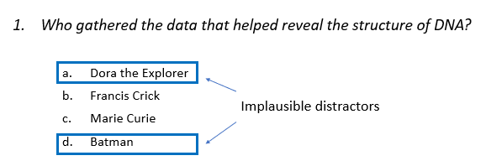

- Go for a ‘best answer’ style key (while avoiding the introduction of subjectivity into the frame) Example
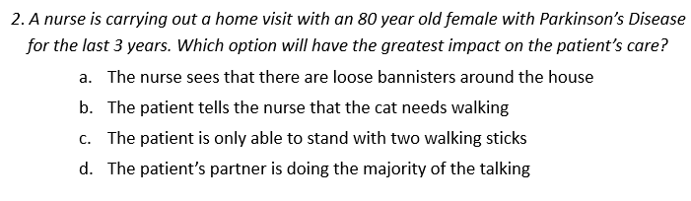

- Incorporate novel visuals (consider accessibility needs) and paraphrase content presented in classes (e.g. questions should not enable direct replication/regurgitation of lecture notes)

Example 1
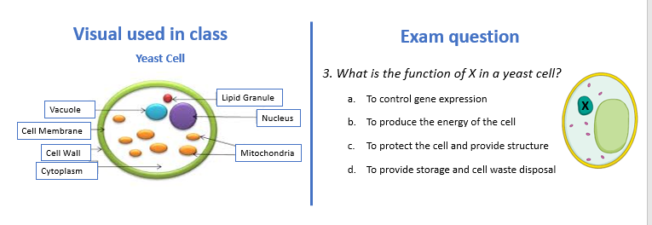
Consider ‘flipping’ the arrangement of concepts and answers. This pre-empts answers that do not require students to have developed an understanding of a concept.

Example 2
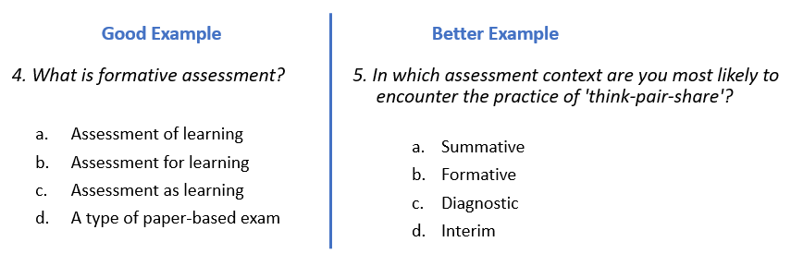
- Use context-dependent item sets or scenario-based questions where possible (e.g. requiring the student to draw on disciplinary knowledge gained programmatically to interpret the scenario and select the most appropriate response). See Example 2 above.

References and further examples:
14 Rules for Writing Multiple-Choice Questions. Brigham Young University, 2011.
This resource provides more examples on different MCQ formats and other strategies for designing higher-order thinking MCQs.
Designing Effective Multiple-Choice Questions. McGill University, Workshop.
This resource links MCQ design with Bloom’s Taxonomy as well as sample MCQ questions to learning outcomes.

Designing Multiple-Choice Questions. University of Waterloo, Centre for Teaching Excellence.
This reference provides examples of MCQ design strategies and provides tips on designing appropriate distractors for MCQ questions.
Scully, D. (2017) ‘Constructing Multiple-Choice Items to Measure Higher-order thinking. Practical assessment, Research and Evaluation. 22(4).
This publication discusses strategies to target higher-order thinking skills in assessment and provides more details on the ‘flipped classroom’ technique in MCQ question design.
Writing Good Multiple Choice Test Questions. Center for Teaching, Vanderbilt University.
This resource provides a quick resource for those designing MCQ questions and uses more MCQ examples to illustrate the guidelines outlined in this document.

Last updated on: 22 April 2021

