Self- & Peer Assessment: a Practical Guide for Students

It is very likely you will be asked to do some form of self- or peer assessment as part of your programme. Self-assessment involves looking at your own work and identifying what is good about it and what needs to be improved. Peer assessment is when you look over, review, or grade another student’s work, so that you can learn from each other and improve your own work. Both self- and peer- assessment are useful in that they can give you a better sense of the strengths and weaknesses of your own work

This resource is intended to support you to understand why self-and peer-assessment are useful and how you can get the most out of them. It looks first at self-assessment and then at peer-assessment.

Self- and peer-assessment can be done easily and effectively using digital technology. Self- and peer-assessment can be used to review any piece of work you create, whether this is a requirement for your module or not. When you get better at critically judging your own work, you can improve the weak points before submitting an assignment. Remember that both peer and self-assessment are much more active form of assessments that just having your lecturer correct your work. You are not waiting for someone else to give you feedback, instead you are doing it yourself. Acting as a critical friend for someone else can help you gain new perspectives on your own work. You might do this by self-assessing your work; peer-assessing a friend or colleague’s work and giving/receiving feedback that you then respond to in your own work; and then re-self-assess your work before its final submission.

Table of Contents
What is self-assessment? 3
Why you should use self-assessment 3
Self-assessment checklist 4
Questions to ask before you submit your work 4
Self-Assessment using digital tools & techniques 5
Comments on word processing software 5
Recordings of your work 6
Review a physical copy of your work 6
Self-assessment timeline 6
Ideal scenario: assignment done well in advance of deadline 6
Realistic scenario: assignment done just before the deadline 9
Printable self-assessment guide 10
After you receive feedback on the assessment 11
Getting to grips with peer assessment 13
What is peer assessment? 13
Why should I use peer assessment? 13
Critical thinking and reflective skills 14
General tips and tricks 14
Social skills, meeting new people 14
How do I use peer assessment? 14
Online meetings 15
Reviewing documents, notes, draft assessments 15
Digital tools and techniques for peer assessment 16
Course/module group chats 16
Comment features of work processors 16
Notes on key takeaways from peer assessments 16

What is self-assessment?
- Self-assessment is when you are involved in judging, evaluating, or commenting on your own work, in any form.
- Self-assessment allows you to identify the weak points of your work so you can improve them and receive better grades.
- Self-assessment can be used evaluate your understanding of module content, to demonstrate that you have achieved a certain outcome or to help you develop core skills such as self-reflection and analysis.
- Self-assessment also allows you to take a more active role in your learning and develop a better judgement for the quality of your work.
- You may be required to self-assess your work by a module leader, however it is also a useful tool to use before submitting any piece or work.
- You may be given a set of criteria to judge your work against (e.g. in a rubric), or just asked to assess your work in a more reflective style.
- Your lecturer/TA may comment on your self-assessment, helping you to address points you have missed in your reflection.
- You will rarely have to formally grade yourself using self-assessment, it mostly involves giving feedback and identifying areas of improvement. However, you can use self-assessment to try and predict the grade you will receive. The better you get a assessing your own work, the better you can tailor your work to match what the lecturer is expecting of you. Self-assessment is particularly useful in a remote context as you are working more independently anyway.

Why you should use self-assessment
Engaging in self-assessment allows you to develop your critical thinking and analytical skills. Improving these skills helps you become a better judge of the quality of your work. You can identify the strengths or weaknesses of the current draft of your work. Most importantly, this allows you to fix the weak points before submitting the assessment. Rather than relying on the lecturer to identify the areas you need to improve, you can use self-assessment to identify and correct these before your work is corrected.

It can be very difficult to objectively judge your own work, however, self-assessment is about developing this skill and learning the right questions to ask yourself to accurately judge the quality of your work. Looking back over your work with a critical lens can give you an insight into what the corrector is looking for and how they will view your work. When assessing your own work, your aim should be to accurately predict the grade a piece of work will receive when corrected. The better you get at identifying the flaws in your own work, the more you can identify them and improve your grades.

The ‘traditional’ assessment process (submit something, get feedback, look to make improvements) involves a dialogue between you and the corrector. This takes time and in large classes it is not always feasible. Self-assessment is about having that dialogue with yourself. Instead of asking the lecturer for feedback, you are asking yourself questions that will prompt you to analyse and improve your work. Using self-assessment means you are not relying on anyone else and develops your own ability to critically judge the weak points of a piece of work.

Self-assessment checklist
Here are some starter questions to try and prompt your own self-assessment.
- When you receive feedback from an assessment, compare it to the questions you asked yourself during self-assessment.
- Are you thinking like the corrector?
- Is there something the corrector raised that you missed in your self-assessment? Remember these points for your next assessment and be sure to address them before submitting.
The more you use this process, the better you will get at asking yourself the right questions to fully critique and analyse your work, so you can improve it before submission.

Questions to ask before you submit your work
☐ Have I answered the question?
☐ Have I shown the corrector that I understand the topic?
☐Have I used appropriate examples?
☐Have I shown critical analysis & developed my arguments?
☐ What are the strengths of this piece of work?
☐ What are the weaknesses?
☐ How can I improve those weaknesses?
☐ Have I made any assumptions that aren’t supported with evidence? Are my arguments logical? Do they flow?
☒ What grade do I think this piece deserves? Why?

Once you receive a grade and feedback for your work:
☐ What grade did I receive? Was I close in the prediction of my grade?
☐ What has the corrector said were the strengths and weaknesses of my work? Does this match what I had predicted?
☐ How can I use what my corrector has said to improve my work in the future?
☐ How do I identify and correct the weaknesses they mentioned before I submit my next assessment?

Self-Assessment using digital tools & techniques
There are many digital tools and techniques you can use to help you develop a process of self-assessment. Using these tools and techniques can make it easier to compare your work and identify what you need to improve on.

Comments on word processing software
Most word processors have a comment feature where you can add notes to certain parts of your work. These are really useful when it comes to self-assessment: adding comments allows you to evaluate your work or flag points you need to address without having to alter your text. Self-assessment is about looking back on your work with a critical view, trying to identify and subsequently fix the weaker points. Adding comments allows you to do this very easily, and you can adjust the text and remove the comments when you are happy with your changes.

Recordings of your work
It can be very helpful to record yourself reading your work out aloud and listening back as a form of self-assessment. It is easy to get wrapped up in a piece of work and forget that someone else may not understand your points in the way you had intended. Listening to your work aloud removes you from your writing and will hopefully allow you to be more objective and critical. This is an especially useful technique for ensuring there are no grammatical errors and that the piece flows nicely.

Review a physical copy of your work
Like with recording your work, printing off and reading a physical copy can be an effective form of self-assessment. Some people find staring at a screen difficult and like to be able to cross things out and write notes to the side.

Different tools and techniques will suit different types of learners. Try to develop a system that works for you. The key with self-assessment is understand what the corrector is looking for and ask yourself: have your produced that? Find a system that allows you to ask the right questions to gauge the quality of your work and make changes to improve it.

Self-assessment timeline
An assignment does not end when you write the conclusion, there is a lot you can do after that point to improve your work. That is when the process of self-assessment really begins. The amount of time until the deadline of the assessment will determine how much self-assessment you will be able to do.

Ideal scenario: assignment done well in advance of deadline
Ideally, you would finish an assignment with more than one week before the deadline. If that is the case, here are some tips on how to use self-assessment to improve your work:
Map out a timeline for your work: when is it due? How long do you need to do the work for it and write up?
- Finish writing the assignment.
- Review your work:
  - Use the questions from the checklist above.
- Wait 2 or 3 days without looking at your work:
- Go back to your work and do another review:
  - Giving yourself a break will allow you to come back to the assessment with a fresh perspective and identity things you missed in the first review. These could be:
    - Unclear or confusing points.
    - Messy sentence structure or poor flow.
    - Assumptions or points that are not well supported.
- Make any necessary changes to your work.
- Repeat this process as many times as you feel is necessary, until you are happy with your work. Or as many times as the time constraints will allow for.
- Submit your work!
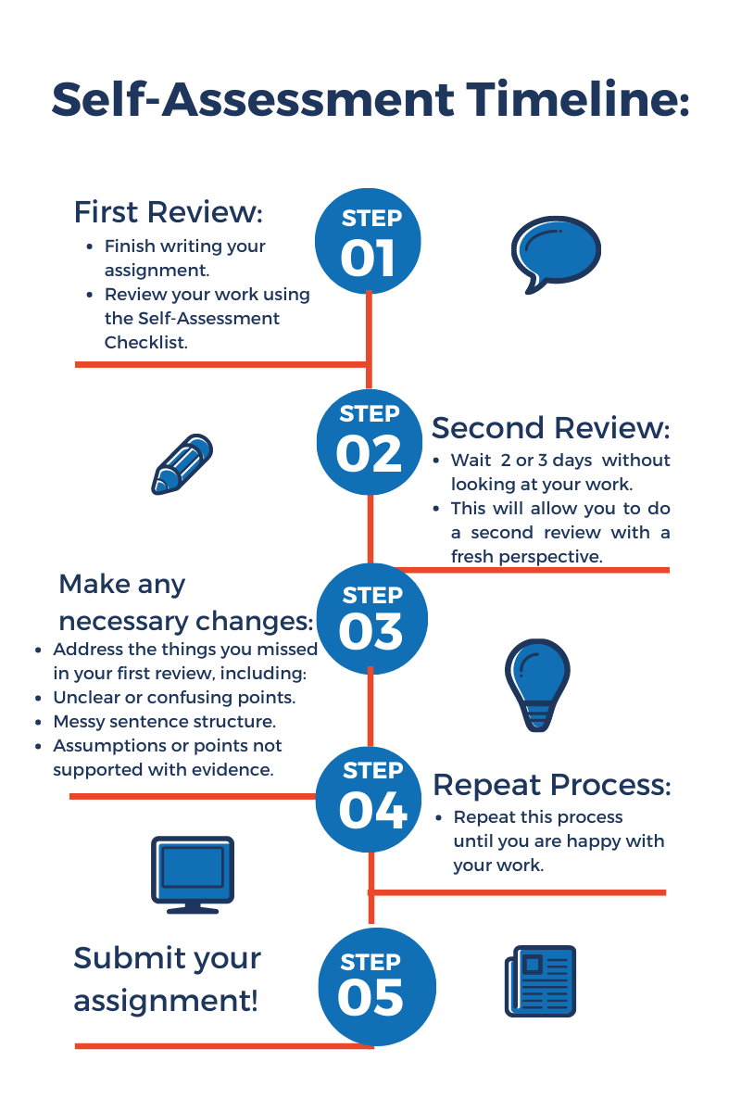

Realistic scenario: assignment done just before the deadline
It is not always the case that you finish an assignment with plenty of time to go, sometimes things get done close to the deadline. It is even more important to use self-assessment in this scenario; if you are rushed doing an assessment, you are more likely to have overlooked a point, misused an example, or included grammatical mistakes. Here are some tips on how to use self-assessment to improve your work if you are short for time:
- Finish writing the assignment
- These are the essentials you should not submit your work without checking:
  - Are you within the wordcount?
  - Have you referenced correctly?
  - Check for spelling & grammatical mistakes.
  - Have you answered the question? Have you included all necessary parts?
- If you have time to spare, ask yourself the questions from the checklist above. Focus of the following elements:
  - Have I done what is required of me in this assessment?
  - What are the most important parts of this assessment? How well do I think I have done those parts? Is there anything I can do to improve those parts?
- Focus on making sure the most important elements of the assessment are of a high quality. They can include:
  - Your main points: Do they make sense? Are there any logical flaws in your arguments? Have you backed them up with examples?
  - Intro & Conclusion: Does the introduction clearly explain what you will do in the assessment? Does the conclusion sum up your arguments?
  - Review your biggest points and most important examples first before moving on to the lesser points. This way you can maximise your time while still using self-assessment to improve your work.

Printable self-assessment guide
What have I done well in this assessment?
(Add details here )
Are there are parts of the assessment I am not happy with? Why?
(Add details here )
What was my process like for completing this assessment? How would I approach this assessment differently if I were to do it again?
(Add details here )
What grade do I think this assessment will receive? Why?
(Add details here )

After you receive feedback on the assessment
What grade did I receive? What was the reasoning for this grade?
(Add details here )
Was I accurate in my predictions of my grades?
(Add details here )
How can I use this advice in future assessments?
(Add details here )

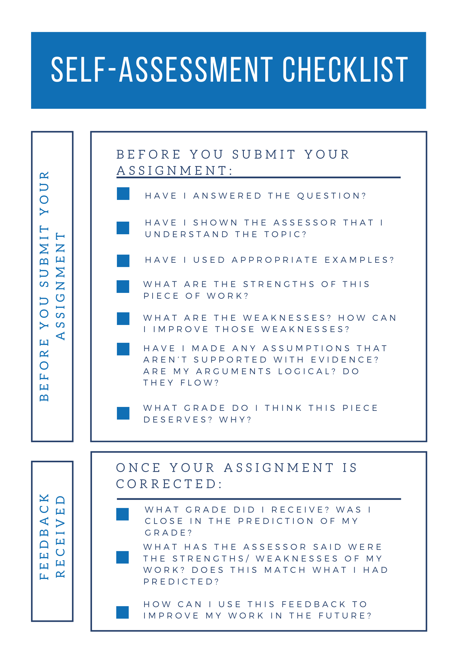

Getting to grips with peer assessment
Peer assessment is when you look over, review, or grade another student’s work, so that you can learn from each other and improve your own work. Using peer assessment allows you to get a better understating of a topic, reading, or assessment. By comparing your work with the work of other students, you can identify your strengths and weaknesses in a particular module or assessment. This allows you to improve those weaknesses before submitting an assessment. Peer assessment also helps you develop your critical thinking and reflective skills and is an excellent opportunity to get to know others in your module or course.

What is peer assessment?
Peer assessment is when you look over, review, or grade another student’s work, so that you can learn from each other and improve your own work. Peer assessment can be either formative or summative. Summative peer assessment counts towards your overall grade in a module, while formative does not. In both types of peer assessment, you review another student’s work to develop your own learning. This resource will focus on formative peer assessment.

Why should I use peer assessment?
Using peer assessment will give you a better sense of the strengths and weaknesses of your own work. By comparing your work to that of your peers, you can gain new perspectives on a topic, learn about interesting examples or ways to approach an assessment. These can be developed and brought into your own work to improve it.

Often you may find yourself confused or unsure about a certain topic or reading in a module. Peer assessment allows you to talk through the topic and compare your knowledge with other students. Organising a peer-assessment session with your peers can act as an informal tutorial class, allowing you to discuss a reading, example or topic, and hear what others think. This can help you gain some clarity or form your own opinions about a topic, which you can use to improve the quality of your assessments.

Critical thinking and reflective skills
By comparing your work with that of another student, you both get a better sense of different arguments or approaches to an assessment that you may have missed. Some of these points may prompt you to think differently or highlight the flaws in your arguments. By comparing your work to that of your peers, you can see the areas you need to improve on and adjust those before submitting an assignment. It can be very easy to get caught up in your own way of thinking about an assessment, so getting a fresh perspective can prompt you to think more critically about your own work. The aim of peer assessment is to compare your work with another student’s so you can learn from each other, which will hopefully improve your final grade in a particular assessment.

General tips and tricks
Using peer assessment is also extremely useful as it allows you to pick up tips and tricks other students have learned over the years. These can cover a range of areas from keyboard shortcuts, referencing tips, useful websites, presentation advice and more.

Social skills, meeting new people
Peer assessment is an excellent opportunity to get to know others in your module or programme. While you can easily arrange to carry our peer assessment with your friends, often it is more beneficial to try and reach out to those you don’t know as well. Not only do you get more varied opinions and insights, you get the chance to meet new people in your course. In a hybrid learning environment, peer assessment group calls can be a great way to get to know others in your course. See below for tips on how to carry out peer assessment in an online context.

How do I use peer assessment?
There are many different ways to carry out peer assessment. It can involve meeting with one or several of your peers to discuss a specific reading, lecture, or assessment, or to talk more broadly about a module. It can also involve sending a draft of your work to another student to mark-up with comments and feedback. Below are some tips to consider so that you get the most out of peer assessment.

Online meetings
- Arrange in advance who will be meeting, how long the meeting will be, and what you plan to discuss. This way the conversation is structured and doesn’t drag on or go off track.
- Take notes throughout the discussion:
  - What interesting points or examples have others made that you hadn’t thought about.
  - How do the points being discussed relate to your own work or understanding about a topic?
  - Are there any readings or resources others have used that may be of use to you?
- After the meeting, write down what you think are the strengths and weaknesses or your own work having heard from other students. Is there something you need to research further to get a better understanding?

Reviewing documents, notes, draft assessments
- Be honest but polite, remember this is a supportive process that both you and your peers can learn from.
- Read through the piece and consider the following elements to help your peer improve:
  - Has this person answered the question?
  - Are their points supported with evidence?
  - Have they used strong examples?
  - What are the strengths/weaknesses of the piece?
- You should also re-read through the piece and see if there is anything you can take from it to improve your own work:
  - Has this piece raised a point I hadn’t considered?
  - Do I need to support my points with more examples?
  - Are there any authors/readings they have referenced that I could research to potentially include in my own work?
  - It may be beneficial to have a short meeting to go over what you both thought of each other’s work.

Digital tools and techniques for peer assessment

Course/module group chats
If you are confused about a topic, or would like someone to review your work, one of the best places to go is your course group chat. If you are comfortable asking the group if anyone wants to arrange a peer review session, do so! While it can be daunting to reach out, there are almost always others who would equally like to work together to improve their learning. Alternatively, talk to your class rep about arranging a set time for students to come together and discuss different modules, readings, or assessments. You could also try contacting someone in your tutorial class or a group project and seeing if they would like to compare work or discuss an aspect of the module.

Comment features of work processors
Most word processors have a comment feature. When reviewing another student’s work, be sure to leave comments relating to the different areas you think they could improve on, or what they have done well.

Notes on key takeaways from peer assessments
Have a document where you compile the various points or pieces of advice you get from different peer review sessions. Some of the points you get will be relevant to all assessments, so be sure to refer to this list when you are completing work in the future.
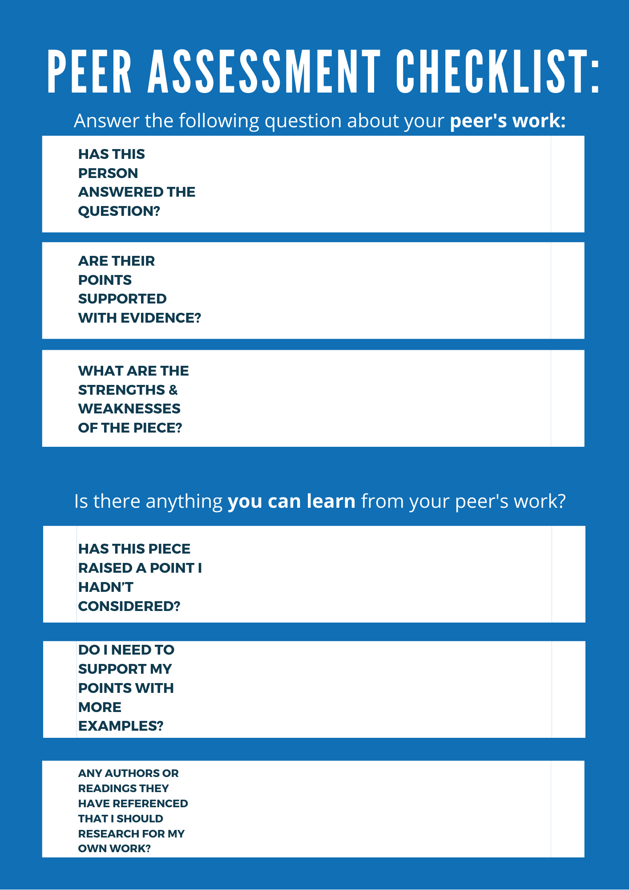
Last updated on: 29 April 2021

