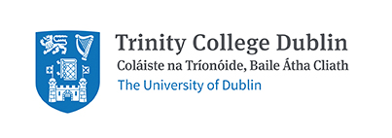
School of Natural Sciences
Ecology, Evolution and the Environment Seminar Series
2018-2019
Hilary Term
Date | Speaker | Title
1-Feb | Vasilis Dakos  Institut des Sciences de l’Evolution de Montpellier | The inevitability of surprise under global environmental change.
15-Feb | Louise Vet  Netherlands Institute of Ecology | Innovation inspired by Nature.
22-Feb | Kate Jones  University College London | One Health: One Planet.
22-Mar | Lukas Hortnagl  ETH Zurich | Swiss FluxNet - Insights and Challenges from 20 years of flux measurements.
29-Mar | Megan Davey  The University of Edinburgh | Walking with the Feet of Dinosaurs.
5-Apr | Kayla King  University of Oxford | Protection and death: rapid coevolution of hosts with their microbial friends and foes.

Seminars will take place between 3-4pm in the Museum Building, lecture theatre M4, TCD. Please direct any enquiries to luijckxp@tcd.ie

