PLEASE RETRURN TO nbrowne@tcd.ie by 17.00, Wednesday, 20 October 2021.
EXPRESSION OF INTEREST FORM for EVENING COURSES
LECTURE COURSE IN CZECH LITERATURE
Božena Němcová and Key Moments in Czech Literary History
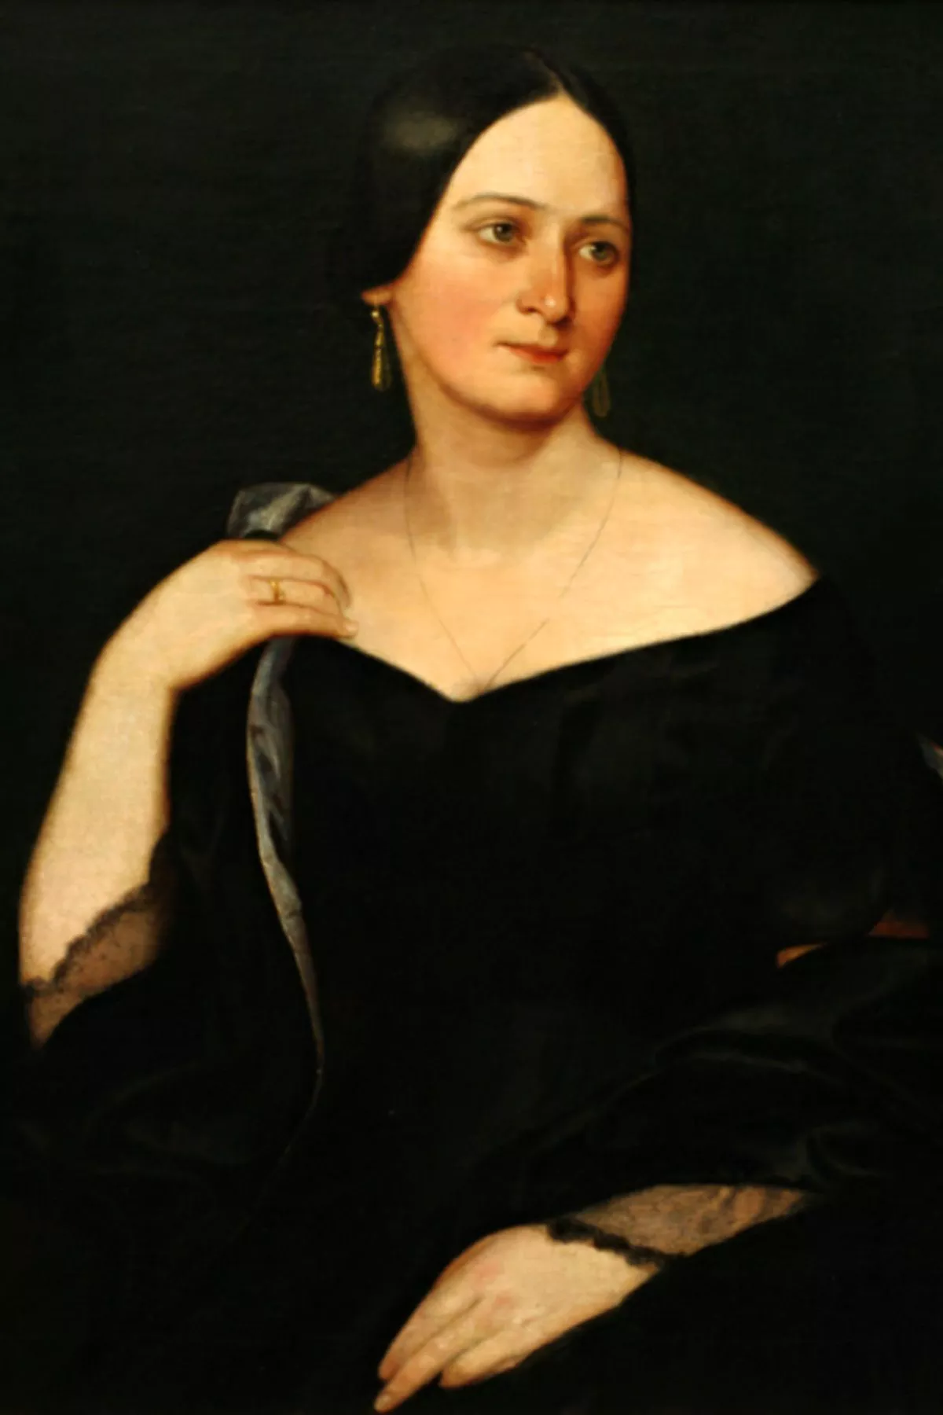
Time: Mondays 7:00-8:30 pm
Duration: 5 weeks
Course fee: €90
Lecturer: Dr Jana van der Ziel Fischerova

- PERSONAL INFORMATION:

Name: _____________________________________________________________________

Email Address: ______________________________________________________________

THANK YOU FOR YOUR INTEREST.
WE WILL EMAIL YOU AFTER 20 October 2021 with registration form and the particulars of payment.

