THE
CENTRE FOR MEDIEVAL & RENAISSANCE STUDIES
TRINITY COLLEGE DUBLIN

CONFLICT & SOCIETY IN SAVOY
1400-1700
LES CONFLITS EN SAVOIE
1400-1700
26-28 May 2010

Thomas Davis Theatre, Arts Building

PROGRAMME

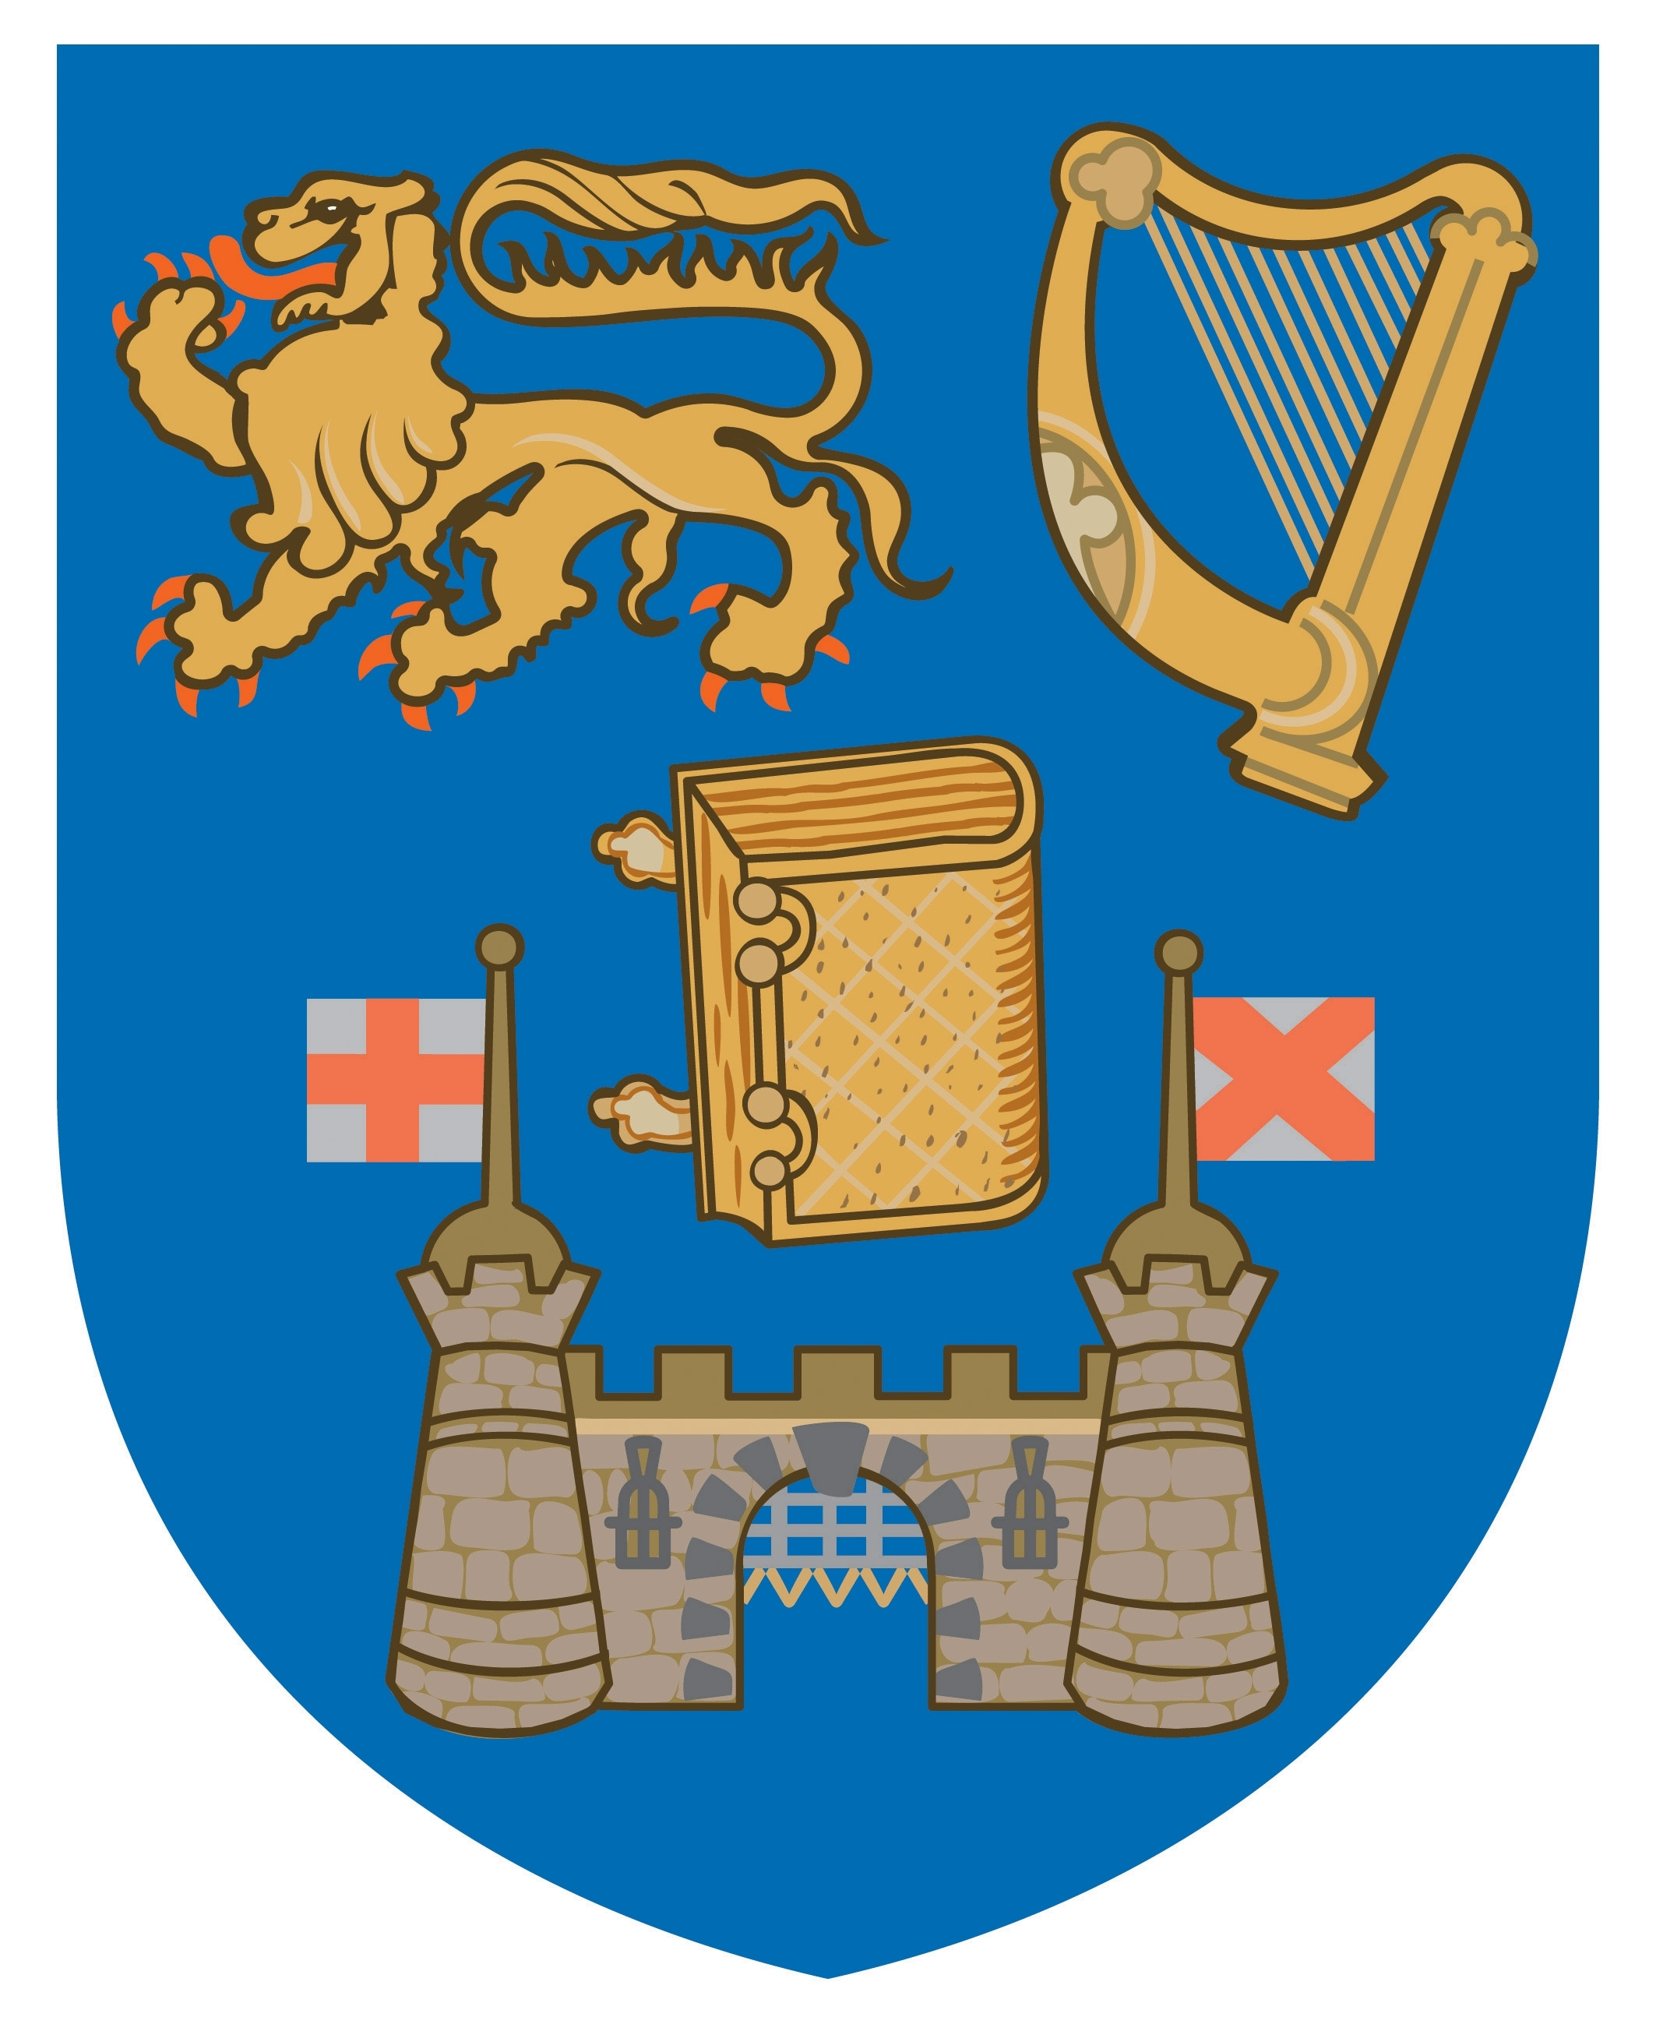

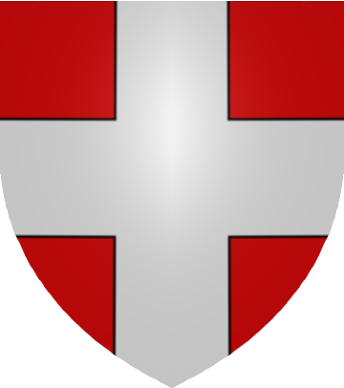
Sponsored by the Long Room Hub
PROGRAMME

NB. Unless indicated otherwise, all talks will take place in the Thomas Davis Theatre in the Arts Building

WEDNESDAY 26 MAY
1.30 p.m. Registration
2.00 p.m. WELCOME
SESSION I: WRITING THE CONFLICT (PART I)
CHAIR: Toby Osborne (University of Durham)
2.15 p.m. -2.45 p.m. Richard Cooper (University of Oxford):
Polemic following the French invasion of Savoy and Piedmont (1536)

2.45 p.m. -3.15 p.m. Roberta Piccinelli (Medici State Archive, Florence):
Amidst Spain, France and Italy: Cultural and Artistic Diversity at the Savoy Court in the mid-16th century

3.15 p.m. -3.45 p.m. Antonella Amatuzzi (University of Turin):
Les libelles vaudois sur les Pâques piémontaises: des armes efficaces dans le conflit avec la cour de Savoie

3.45 p.m. -4.15 p.m. Refreshments (Arts Building Concourse)

SESSION II: WRITING THE CONFLICT (PART 2)
CHAIR: Matt Vester (West Virginia University)
4.15 p.m. -4.45 p.m. Stefania Vignali (University of Turin):
Lettres, memoires, relations: les mots qui racontent le printemps de sang de 1686

4.45 p.m. -5.15 p.m. Paolo Cifarelli (University of Turin):
Raconter le conflit: une correspondence parisienne et l’affaire des Vaudois (1655)

5.15 p.m. -5.45 p.m. Jill Fehleison (Quinnipiac University):
The Place of the Cross: the Pamphlet Battle between François de Sales and Antoine de la Faye

6.00 p.m. Reception (1592 Upper Lunch Room)

THURSDAY 27 MAY
SESSION III: DIPLOMACY AND POLITICS (PART 1)
CHAIR: Richard Cooper (University of Oxford)
9.30 a.m.-10.00 a.m. Rebecca Boone (Lamar University):
From Piedmont to Tenochtitlan: Mercurino di Gattinara’s Approach to Occupation and Social Conflict

10.00 a.m.-10.30 a.m. Fabrice Micallef (University of Paris I-Panthéon Sorbonne):
‘Je viens de l’école’: Les apprentissages politiques de Charles-Emmanuel de Savoie pendant son intervention en Provence (1590-1592)

10.30 a.m.-11.00 a.m. Blythe Alice Raviola (University of Turin):
War and Peace: Sabaudian Diplomacy and the Succession Conflicts of Mantua and Monferrato (1612-1631)

11.00 a.m.-11.30 a.m. Refreshments (Arts Building Concourse)

SESSION IV: DIPLOMACY AND POLITICS (PART 2)
CHAIR: Blythe Alice Raviola (University of Turin)
11.30 a.m.-12.00 a.m. Toby Osborne (University of Durham):
Savoy's royal claims and the control of titles of address

12.00-12.30 p.m. Laura Ghiosso (University of Turin):
Le discours diplomatique dans le conflit pour le contrôle des Cantons catholiques: les Instructions aux ministres à l’époque de Charles-Emmanuel II

12.30 p.m. -2.00 p.m. Lunch

SESSION V: DIPLOMACY AND POLITICS (PART 3)
CHAIR: Graeme Murdock (Trinity College Dublin)
2.00 p.m. -2.30 p.m. Matt Vester (West Virginia University):
The Position of the Vallée d’Aoste in International Politics during the Late Renaissance

2.30 p.m. -3.00 p.m. Maria Sole Bionaz (Lycée Bérard, Aosta):
Adelaϊde-Charlotte de Savoie et la visitation d’Aoste

3.00 p.m.-3.30 p.m. Refreshments (Arts Building Concourse)

3.30 p.m.-5.00 p.m. Visit to Trinity’s Old Library; presentation of Waldensian texts and manuscripts in the Henry Jones Room

6.00 p.m. ‘Commons’ (dinner) in the East Dining Hall (hosted by the Centre)

FRIDAY 28 MAY
SESSION VI: THE CHURCH IN CONFLICT (PART 1)
CHAIR: Sarah Alyn Stacey (Trinity College Dublin)
9.00 a.m.-9.30 a.m. Sandro Lombardini (University of Turin):
Contentious religious proximities: Abbeys and their Waldensian leaseholders in the Valleys of Susa, Chisone, Pellice and Germanasca (15th-17th centuries)

9.30 a.m.-10.00 a.m. Marco Battistoni (Centro Interuniversitario di storia territoriale ‘Goffredo Casalis’):
Topography of Dissent: Waldensian Settlements and Abbatial Domains in
the Marquisate of Saluzzo and Southern Piedmont (Late 15th to Mid 17th Centuries)

10.00 a.m.-10.30 a.m. Federico Bo (University of Turin):
I manoscritti valdesi di Dublino: i sermoni ed il lezionario del ms. Du267

10.30 a.m.-11.00 a.m. Cornel Zwierlein (Ruhr University Bochum):
Between Tolerance and Suppression: the Waldensians, the Duke of Savoy and the International Context of Religious Conflicts in the Second Half of the 16th Century

11.00 a.m.-11.30 a.m. Refreshments (Arts Building Concourse)

SESSION VII: THE CHURCH IN CONFLICT (PART 2)
CHAIR: Jill Fehleison (Quinnipiac University)
11.30 a.m.-12.00 Alfonso Tortora (University of Salerno):
Waldensians of Piedmont in the First Modern Age

12.00-12.30 p.m. Elisabetta Lurgo (University of Piemonte Orientale):
The Historia della più occidentale Italia by Guglielmo Baldessano: monstruous births, prophecy and heresy in Savoy Piedmont

12.30 p.m. -2.00 p.m. Lunch
SESSION VIII: THE CHURCH IN CONFLICT (PART 3)
CHAIR: Cornel Zwierlein (Ruhr University Bochum)
2.00 p.m. -2.30 p.m. Alessandro Celi (University of Udine):
Religious Persecution: Origin and Causes of the Torgnon and Antey Interdict (1417-1555)

2.30 p.m. -3.00 p.m. Marina Benedetti (University of Milan):
Inquisitorial Trials against the Waldensians in Trinity College Library

3.00 p.m.-3.30 p.m. Refreshments (Arts Building Concourse)

3.30 p.m.-4.30 p.m. Round Table Discussion: future directions for a research network

END OF CONFERENCE

