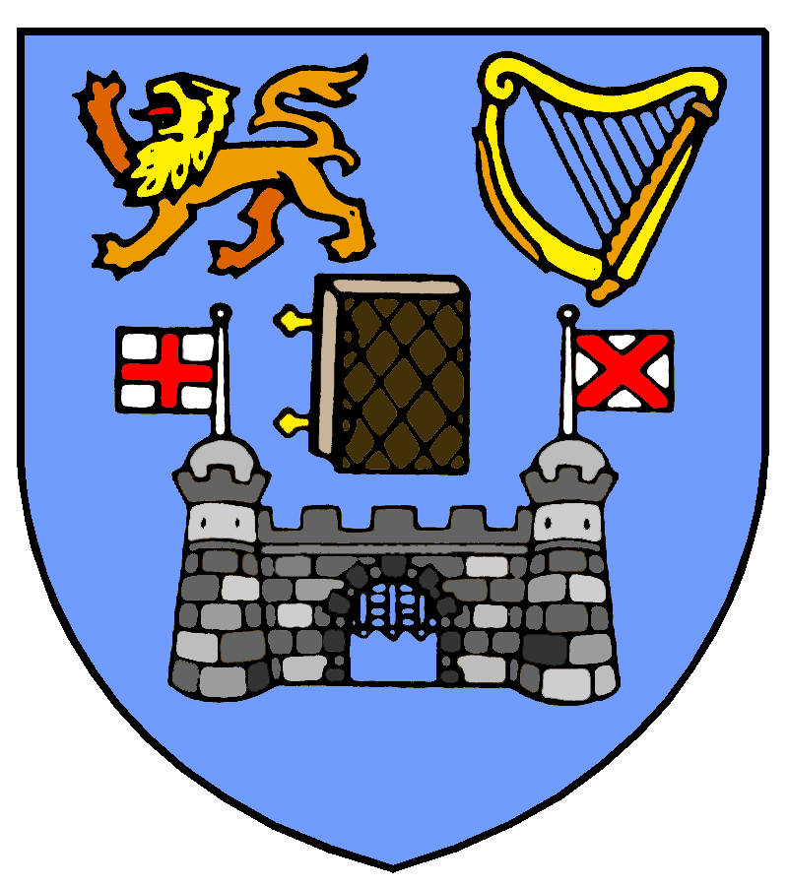
The Centre for Medieval and Renaissance Studies
Trinity College Dublin
FORUM FOR THE STUDY OF EARLY MODERN WOMEN
IN CONTINENTAL EUROPE

Forum Launch & First Interdisciplinary Colloquium:
Thursday 2nd – Friday 3rd September 2010
Swift Theatre, Arts Building, TCD
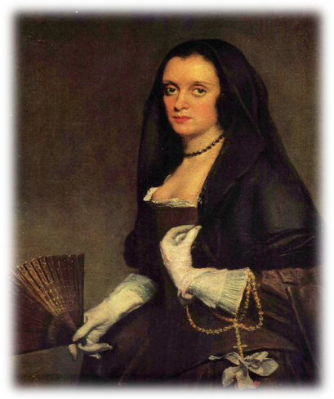

We are sincerely grateful to our sponsors:
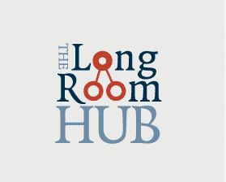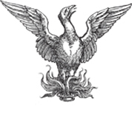
Thursday 2nd September:
1.00-1.30 Registration
1.30-1.45 Welcome by Forum Coordinator, Eavan O’Brien (Trinity College Dublin) & Forum Launch by John Law (Swansea University; former Honorary Chair, Society for Renaissance Studies)

1.45-3.15 Saints, Sinners, and Early Modern Morality
Chair: Victor Dixon (Trinity College Dublin)
Sarah Alyn Stacey (Director, Centre for Medieval & Renaissance Studies, Trinity College Dublin): “Tourmenter, tuer et damner les hommes”: Women and Vice in Marguerite de Navarre's Heptaméron
Peter Lahiff (University College Dublin): From Belgian Witches to Roman Madams: The Portrayal of Early Modern Women in the Medical Writings of Dr Andrés Laguna
Mahe Nau Awan (University of Surrey): Paradise Lost and the Conflicting Virtues of Early Modern Continental Europe

3.15-3.45 Tea/Coffee

3.45-5.45 European Debates, Influence, and Exchange
Chair: John Walsh (Trinity College Dublin)
Danielle Clarke (University College Dublin): Poetic Exchanges: Early Modern Women's Poetry and Continental Influence
Kathrin Schlierkamp (Ludwig Maximilian University of Munich): Mind the Gap: 17th-Century Women on Soul and Body
Rózsa Réka (Independent Scholar, Milan): “Donne…. Dio me liberi!”: Querelles des femmes on the Early Modern Stage
Gábor Gelléri (NUI Galway): Travel to England as a Gendered Experience

6pm Reception & Opportunity for Informal Discussion of Future Research:
The Cocktail Room, O’Neill’s Pub, Suffolk Street

Friday 3rd September:
9.00-10.30 Literary ‘Foremothers’ in Continental Europe
Chair: Eavan O’Brien (Trinity College Dublin)
Linda Grant (Birkbeck, University of London): Uncovering Sulpicia – a Classical Roman Model for Veronica Franco?
Marcela Vavrinova (Masaryk University): The Portrayal of Women and Female Community in the Book of Margery Kempe
Carmen Dutu (Dimitrie Cantemir University): Eros and history: Ways of Thinking Gender in the Romanian 18th Century

10.30-11.00 Tea/Coffee

11.00-1.00 Women Writers of the Spanish Empire
Chair: Isabel Torres (Queen’s University, Belfast)
Lesley Twomey (Northumbria University): Female Authority in the Vita Christi of Isabel de Villena
Anne Cruz (University of Miami): Zayas, Cervantes, and the Seven Deadly Sins
Elizabeth Rhodes (Boston College): María de Zayas and Saint Beatriz of Hungary
Anthony Lappin (University of Manchester): Lucretia’s Suicide: Sor Juana Inés de la Cruz's Sonnets in Praise of the Deed

1.00-2.00 Buffet Lunch:
Arts Building Concourse, TCD

2.00-4.00 Women of Means: Society, Politics, and Opportunities
Chair: Derval Conroy (University College Dublin)
Lia van Gemert (University of Amsterdam): Seizing Opportunities: Women Writers in the Dutch Republic between 1600 and 1800
Adelina Modesti (La Trobe University): The Self-fashioning of a Female “Prince”: The Cultural Matronage of Vittoria della Rovere
Sarah Bercusson (Queen Mary, University of London): Expressing Identity and Allegiance at the Italian Renaissance court: The Problem of the Female Consort
Mercedes Llorente (University College London): Portraits of Queen Mariana of Spain as Curadora (1671-1680)

4.00-4.30 Tea/Coffee

4.30-5.30 18th-Century Women
Chair: Sarah Alyn Stacey (Trinity College Dublin):
Mike & Kathleen Mary Nolan (La Trobe University): “Ne Scavoir Signer”: Recovering Voices from the Sarthe Region of 18th-century France
John Law (Swansea University): Women Makers of the Italian Renaissance – in Victorian and Edwardian Times

* * * End of Colloquium * * *

