THE
CENTRE FOR MEDIEVAL & RENAISSANCE STUDIES
TRINITY COLLEGE DUBLIN
&
THE SCHOOL OF CULTURES, LANGUAGES & AREA STUDIES, UNIVERSITY OF LIVERPOOL

invite you to a three-day international conference

READING ANTHOLOGIES IN RENAISSANCE EUROPE 1450-1650
19-21 July 2010

Thomas Davis Theatre, Arts Building, TCD

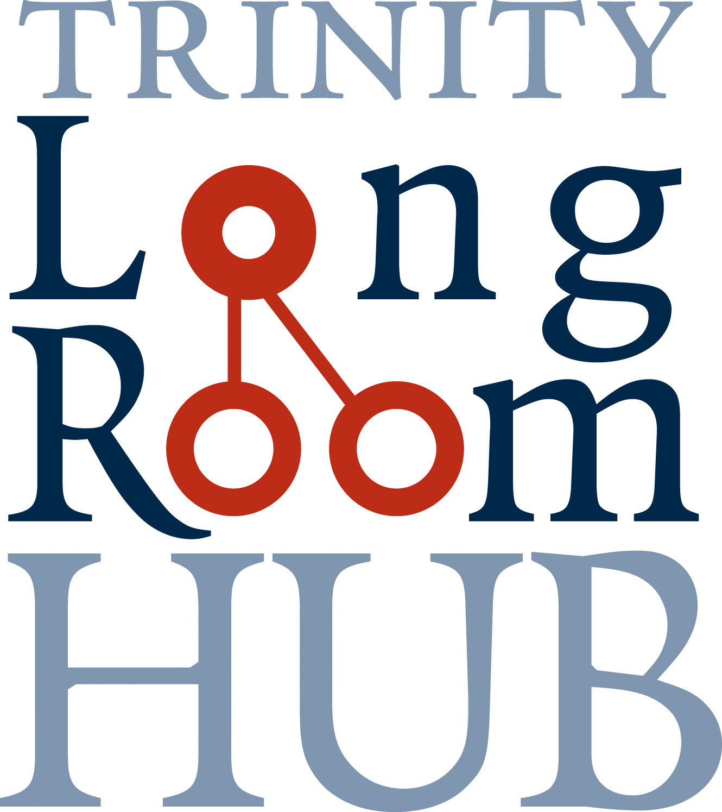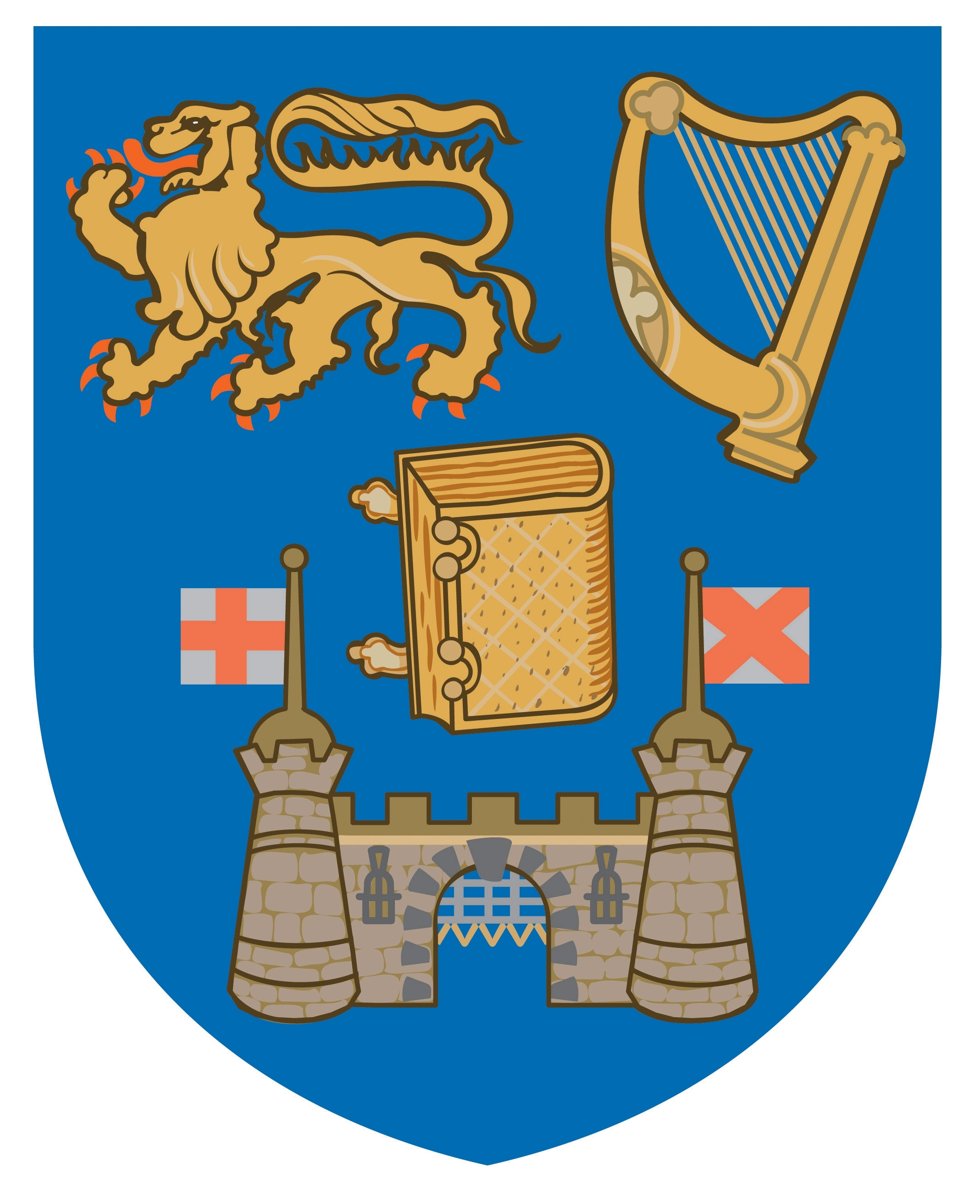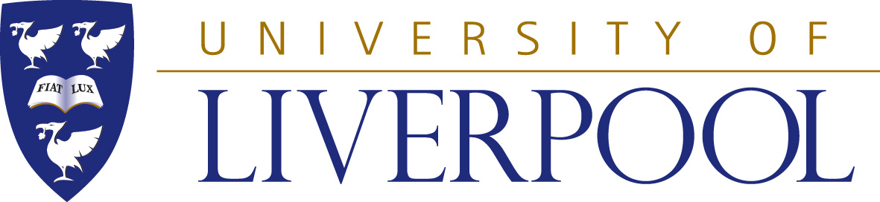

This is the second stage of a two-part project to highlight the Renaissance holdings in the Old Library of Trinity College Dublin. The first stage, a three-day international conference Conflict and Society in Savoy 1400-1700 (26-28 May 2010), was constructed around the College’s rare Waldensian manuscripts. This second stage will look at anthologies in a European context.
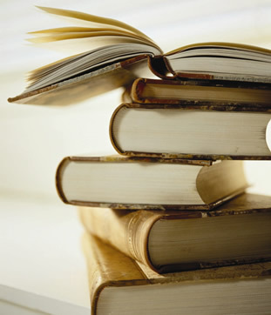
Sponsored by the Long Room Hub

For full details, contact: Dr Pollie Bromillow; e-mail: Pollie.Bromilow@liverpool.ac.uk; Dr Sara Barker; e-mail: S.k.Barker@warwick.ac.uk; Dr Sarah Alyn Stacey; e-mail: salynsta@tcd.ie; tel: 01-896 2686; website: www.tcd.ie/Medieval_Renaissance
THE
CENTRE FOR MEDIEVAL & RENAISSANCE STUDIES
TRINITY COLLEGE DUBLIN

&
THE SCHOOL OF CULTURES, LANGUAGES AND AREA STUDIES, UNIVERSITY OF LIVERPOOL

READING ANTHOLOGIES IN RENAISSANCE EUROPE
1450-1650
19-21 July 2010

Thomas Davis Theatre, Arts Building, TCD

PROGRAMME

Sponsored by the Long Room Hub
Monday 19th July 2010

1.30pm-2pm Tea, Coffee and Registration

2pm Welcome
Professor Poul Holm, Director, Long Room Hub

2.15pm-3.15pm Keynote Lecture 1
Professor Paul Smith (University of Leiden):
‘Anthologizing Tendencies in Early Modern French Fable Books’

3.15pm-3.45pm Tea, coffee and biscuits

3.45pm-5.15pm Panel 1 – Constructing Anthologies
Stefanie Lethbridge (Albert-Ludwigs-Universität Freiburg): ‘Sixteenth-century Poetry Anthologies and the Formation of National Cultural Memory’

Michael Hetherington (Magdalene College, Cambridge): ‘Anthological structures: George Gasgoine’s A Hundreth Sundrie Flowres, Miscellaneity, and Elizabethan Logic’

Don Cruickshank (University College, Dublin): ‘Printed Anthologies of Classical Spanish Drama’

5.30-6.00pm Presentation on Iberian Books Project by Dr Alexander Wilkinson, University College, Dublin

6.00pm Drinks Reception (Upper Lunch Room of the Dining Hall)

7.30pm Dinner (at own expense) at Fallon and Byrne, 11-17 Exchequer Street,

Tuesday 20th July

9.30am-11.00am Visit to Trinity College Dublin Library

11.00-11.30am Tea, coffee and biscuits

11.30am-12.30pm Keynote Lecture 2
Professor Andrew Pettegree (University of St Andrews):
'The perils of plenty: Anthologising and its dangers'

12.30pm-2.00pm Lunch

2.00pm-3.30pm Panel 2 - Commercial Imperatives in Anthologisation
Maiko Favaro (Scuola Normale Superiore di Pisa): ‘Longevity and Progressive Moralization of the Lyrical Anthologies through the Metaphor of the “Temple”: the Case of the “Temples of Poems” in Renaissance Italy’

Randall Anderson (Independent Scholar): ‘Reading the White Space of Tudor Verse Miscellanies’

Élise Rajchenbach-Teller (Université de Paris III) : ‘The Deploration de Venus sur la mort du bel Adonis : A Successful Anthology in Mid-16th Century Lyons’

3.30pm-4.30pm Panel 3 – Receiving and Reading Anthologies
Lisa Kaborycha (The Harvard Center for Italian Renaissance Studies at Villa I Tatti): ‘The social world of Renaissance Florentines as viewed through their Zibaldoni anthologies’

Véronique Adam (Université de Toulouse): ‘Editing Anthologies of poetry (1597-1626): A literary strategy’

4.30pm-5.00pm Tea, coffee and biscuits

5.00pm-6.00pm Panel 4 – Rethinking Anthologies
Nelleke Moser (VU University Amsterdam): Nested Texts: Dutch Printed Anthologies containing ‘booklets’ in manuscript and print

Florence d’Artois (Université d’Artois): ‘From constructive ambiguity to ambivalent reading: a study on the phenomenology of reading of Spanish baroque miscelánea (1604-1640)’

7.30pm Dinner (at own expense) at The Millstone, 39, Dame Street

Wednesday 21st July

9.30-10.30am Panel 5 – Anthologies and their Impact
Ken Kurihara (Fordham University): ‘The Power of News Collection: Hiob Fincel’s Wunderzeichen and the Apocalyptic Conviction of the Lutheran Faith in 16th Century Germany’
Sara Barker (University of Warwick): ‘And now for something completely different? Gathering News in English Translation in Renaissance Europe’

10.30am-11.00am Tea, coffee and biscuits.

11.00am-12.00pm Keynote Lecture 3
Dr Carrie Griffin (University College Cork):
‘Useful Anthologies: The case of 'Practical Texts' in Medieval and Early Modern Book Culture’

12.00pm-1.00pm Conference Roundtable and close.

