THE DEPARTMENT OF HISPANIC STUDIES
TRINITY COLLEGE DUBLIN

The Department is very happy to announce the visit of
Dr Carlos Larrinaga Rodríguez
Department of Economic Theory and History at the University of Granada
who will give a lecture entitled
Introducción a la Historia Económica de la
España Contemporánea
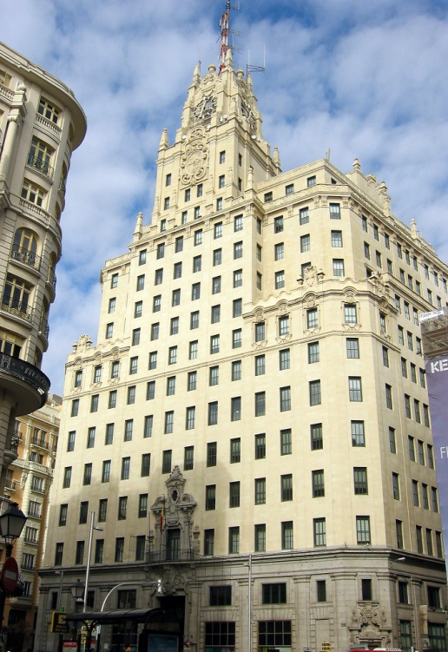
Telefónica (Madrid, 1924)

Tuesday 6 December 2 p.m. Room 3070
Thursday 8 December 10 a.m. Room 3051

