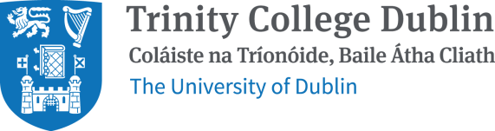

REGISTRATION FORM

JAMES JOYCE: ULYSSES 1922–2022
XXVIII INTERNATIONAL JAMES JOYCE SYMPOSIUM
12–18 June 2022
Trinity College Dublin
University College Dublin

Fill in all sections of the form below. Save the form as a Word document, naming the file in the following format: Surname_Initial_dublinjoyce2022.
Email the form to Ulysses100@tcd.ie

PERSONAL DETAILS
Title and name
Preferred pronouns
Email address
Institutional affiliation
Student or unwaged (yes/no)
Presenting a paper at conference (yes/no)
Letter of acceptance required (yes/no)
Phone
Postal address
Dietary requirements
Attending Bloomsday banquet (yes/no)

AVAILABILITY
The conference runs from 12–18 June. If you cannot attend any of these dates, let us know below.

