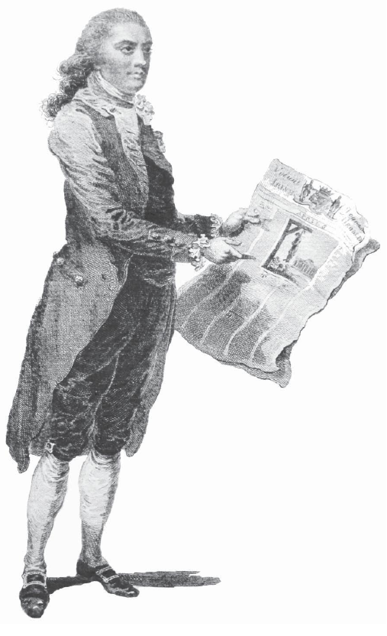
Ireland, America and the
Worlds of Mathew Carey

Trinity Long Room Hub
Trinity College Dublin
17-19 November 2011

Conference Registration

Name:

Email Address:

Institutional Affiliation (optional):

Will you be attending the Keynote Lecture in the National Library of Ireland on Thursday 17th November, 6pm followed by a reception? Please underline Yes or No
Yes No

Will you be attending the Conference Dinner in Bang Restaurant on Friday 18th November, 6.30pm? Please underline Yes or No
Yes No

For any further information please email CareyConferenceDublin@gmail.com

