School Name

Title (PGT) Programme Handbook

AY XX/XX

Table of Contents
- General Course Information 2
  - Introduction 2
  - Contact Details 2
  - Key Locations 2
  - Key Dates 3
  - Timetable 4
  - Internships/Placements for Credit 5
- Scholarships and Prizes 5
- Academic Writing 5
  - Academic Integrity and Referencing Guide 5
  - Research Ethics 6
- Teaching and Learning 6
  - Programme Structure 6
  - Programme Structure and Workload 6
  - Postgraduate Taught Research Models 7
  - Learning Outcomes 7
  - Module Descriptors & Compulsory Reading Lists 8
  - Coursework Requirements 8
  - Marking Scale 8
  - Attendance Requirements 9
  - Absence from Examinations 9
  - External Examiner 9
  - Progression Regulations 10
  - Awards 10
  - Professional and Statutory Body Accreditation (if applicable) 10
  - Careers Information and Events 11
  - Student Feedback and Evaluation 11

GENERAL COURSE INFORMATION

Introduction
To be written by the Course Director or their nominee. Click or tap here to enter text.

Contact Details
Course related information to be included alongside the relevant member of staff, e.g., the course on which a staff member may act as a module coordinator, etc.
To include Head of School, DTLPG, School Administrator, Module Coordinator, and relevant School Support Staff. It is good practice to provide two methods of contact, e.g., email and phone number or office location and hours of opening.

Staff Name | Role/Title | Contact 1 | Contact 2

Key Locations
May include programme offices, laboratories, online learning environments, libraries, Academic Registry, places of faith/prayer rooms, photocopiers and any relevant introductory information on these locations.

References/Sources: Interactive College Map Blackboard
Academic Registry

Key Dates
Important dates and submission deadlines

Important Dates
WEEK | DATE | MICHAELMAS TERM (Insert relevant year)
3 |  | Lectures begin in all modules
4 |  | Tutorials begin from this week
7 |  | Submission of assignment 1: ‘Name of module’
7 |  | Reading Week
9 |  | Submission of assignment 1: ‘Name of module’
11 |  | Submission of assignment 1: ‘Name of module’
12 |  | Submission of assignment 2: ‘Name of module’
12 |  | Submission of assignment 2: ‘Name of module’
 |  | Teaching ends
 |  | Submission of assignment 2: ‘Name of module’
WEEK | DATE | HILARY TERM (insert relevant year)

1 |  | Lectures begin in all modules
2 |  | Tutorials begin from this week
6 |  | Submission of assignment 1: ‘Name of module’
7 |  | Reading Week
8 |  | Submission of assignment 1: ‘Name of module’
9 |  | Submission of assignment 1: ‘Name of module’
11 |  | Submission of assignment 2: ‘Name of module’
12 |  | Submission of assignment 2: ‘Name of module’
 |  | Teaching ends
 |  | Submission of assignment: ‘Name of module’
 |  | Submission of assignment 2: ‘Name of module’

Click or tap here to enter text.

Reference/Source: Academic Year Structure

Timetable
Where the timetable is available through MyTCD, provide a statement on this. Where it is published elsewhere, provide a clear statement on accessibility of timetable.

Click or tap here to enter text.

Reference/Source: My TCD

Internships/Placements for Credit
To include information about field trips, professional placements or internships. Click or tap here to enter text.

Reference/Source:
Internships and Placements Policy

SCHOLARSHIPS AND PRIZES

Locally awarded items, including eligibility and information on how each item is awarded.

ACADEMIC WRITING

Academic Integrity and Referencing Guide
Standard Text to be copied from the Calendar with a link to the Academic Integrity Policy (currently in development) and the Statement of Principles on Academic Integrity included.
A link to the Library Guidelines on Academic Integrity and a link to the declaration text for submitted assignments.
Should there be local policy on referencing or programme copy of the coversheet declaration, relevant links and/or details to inform students.
Click or tap here to enter text.

References/Sources:
Calendar Part III, Section 1: General Regulations & Information, 'Academic Integrity' Statement of Principles on Integrity
Academic Integrity Policy (currently in development)

Library Guides – Academic Integrity Coversheet Declaration

Research Ethics
On relevant programmes, Schools should provide relevant links and information regarding good practice in research, as well as provide information on College and Faculty policies and procedures.
Click or tap here to enter text.

References/Sources: Research Ethics
Policy on Good Research Practice Ethics Policy

TEACHING AND LEARNING

Programme Structure
Information on the course structure and the available award/s and exit award a Postgraduate Certificate, Postgraduate Diploma, or Masters. A statement on the QQI – NFQ Level must be included.
Click or tap here to enter text.

Programme Structure and Workload
List of modules identified by title and code, their ECTS weightings, and a general statement on the learning workload to include approximate hours of self-directed learning or research.

Module Title | Module Code | ECTS Weighting | Learning Workload

Click or tap here to enter text.

Reference/Source:
Policy on Trinity Virtual Learning Environment

Postgraduate Taught Research Models
The model(s) for PGT research components selected by the course director for the programme should be outlined in the programme handbook. More than one model may be employed per course.
Click or tap here to enter text

Reference/Source:
5 Model Framework for Postgraduate Taught Research

Learning Outcomes
Course level learning outcomes at the programme level for each of the available postgraduate awards offered.
Click or tap here to enter text.

Module Descriptors & Compulsory Reading Lists
Standard Text: The School reserves the right to amend the list of available modules and, in particular to withdraw and add modules. Timetabling may restrict the availability of modules to individual students.
Insert Full Module Descriptors for all Modules (core/mandatory and optional) which are part of the course structure.
Click or tap here to enter text.

Coursework Requirements
In-course assessment and examination arrangements, grade descriptors, rubrics for all assessment components, as well as guidelines on presentation and submission of work for assessment purposes (including details of penalties applied for late submission, word count and coversheet declaration).
Reference to academic support services or online modules may be relevant here. Include guidance to ensure any written work is in line with Trinity’s Accessible Information Policy (i.e. use of sans serif font [e.g. calibri]; minimum size 12).

Click or tap here to enter text.

Reference/Source:
Student Learning Development Accessible Information Policy

Marking Scale
Click or tap here to enter text.

Attendance Requirements
Both College-level and course-level requirements should be provided to include information regarding self-certification procedures and where medical certificates should be returned.
Where the professional statutory accreditation bodies specify attendance requirements including those that apply to professional placements, these should also be in the handbook.
Click or tap here to enter text.

Reference/Source:
Calendar Part III, Section I: General Regulations and Information, 'Attendance and Off-Books'; Section III 'Attendance, Registration, Extensions'; Section IV 'Attendance and Examinations'

  - Absence from Examinations Standard Text to be copied from the Calendar Click or tap here to enter text.

Reference/Source:
Calendar Part III, Section III: 'Examinations, Assessment and Progression'; Section IV: 'Attendance and Examinations'
Academic Policies

External Examiner
The name and title of the External Examiner.
If the External Examiner is from outside the EU/EHEA, the student needs to be informed that their personal information, i.e., exam script, is going outside the EU/EHEA.
Click or tap here to enter text.

Reference/Source:
Procedure for the Transfer of Students’ Assessed Work to External Examiners

Progression Regulations
Click or tap here to enter text.

References/Sources:
Calendar, Part III, Section III 'Examinations, Assessment and Progression' and 'Assessment and Progression Regulations'
National Framework for Qualifications Trinity Courses

Awards
For postgraduate taught programmes, e.g. P.Grad.Cert, P.Grad.Dip, or Masters, where Exit Awards (P.Grad.Dip) exist, this information must be included.
A statement on the QQI – NFQ Level must be included. Click or tap here to enter text.

References/Sources:
National Framework for Qualifications Trinity Courses

Professional and Statutory Body Accreditation (if applicable)
Where the course is subject to professional accreditation, provide an overview of additional requirements and links to the body and relevant policies.
Click or tap here to enter text.

Careers Information and Events
Specific to the course.

Student Feedback and Evaluation
Statement on College requirements for evaluation and feedback, as well as an outline of additional feedback practices at a local level.
Click or tap here to enter text.

References/Sources:
Student Evaluation and Feedback Student Partnership Policy
Procedure for the conduct of Focus Groups for Student Feedback on Modules and Programmes

School Name

Title of Handbook AY XX/XX

TABLE OF CONTENTS
- General Regulations 1
- Student Services 1
  - Academic Support 7
  - Health and Wellbeing Support 7
  - Getting Involved 7
  - Financial Support 8
  - Administrative Support 8
  - Your Tutor 8
  - Postgraduate Advisory Service 9
  - The Academic Registry 10
  - Information on key campus locations 10
  - Student Representation and Governance 11
  - Careers Information 11
- Academic Writing 11
  - Academic Integrity and Referencing Guide 11
  - Research Ethics 12
- General Information 12
  - Emergency Procedure 12
  - Health and Safety Statements 13
  - Data Protection 13
  - Explanation of ECTS Weighting 13
  - Links to Further University Policies and Procedures 14

Trinity Visual Identity Guidelines
Accessible Information Policy

Note: This document is a template for Schools/Disciplines. There may be additions/amendments appropriate to the needs of an individual School that reflect the local regulations of the School/Discipline and are in accordance with the Calendar.

GENERAL REGULATIONS
Standard Text: In the event of any conflict or inconsistency between the General Regulations published in the University Calendar and information contained in programme or local handbooks, the provisions of the General Regulations in the Calendar will prevail.

Reference/Source Calendar
Calendar Part II, Part B: General Regulations and Information

Calendar Part III, Section 1: General Academic Regulations

- STUDENT SERVICES
Student Services has developed the handbook (embedded below) outlining the support services provided to undergraduate and postgraduate students. The handbook and further information is available from their website and in the Student Services Handbook. School/Department Handbooks can provide a link to the PDF or embed the PDF within the Handbook itself.

Reference/Source: Student Supports & Services

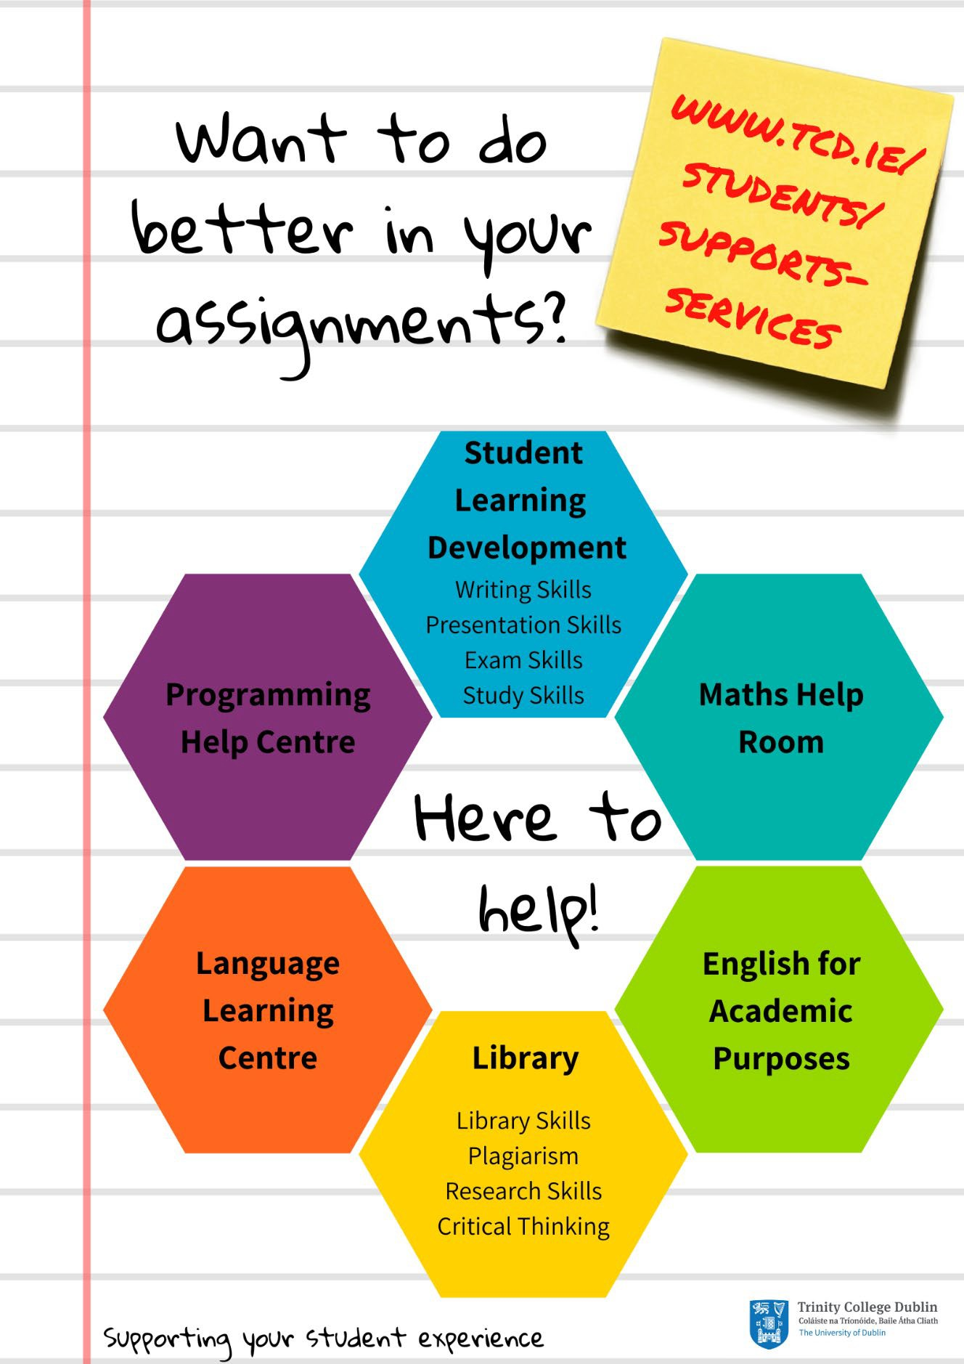

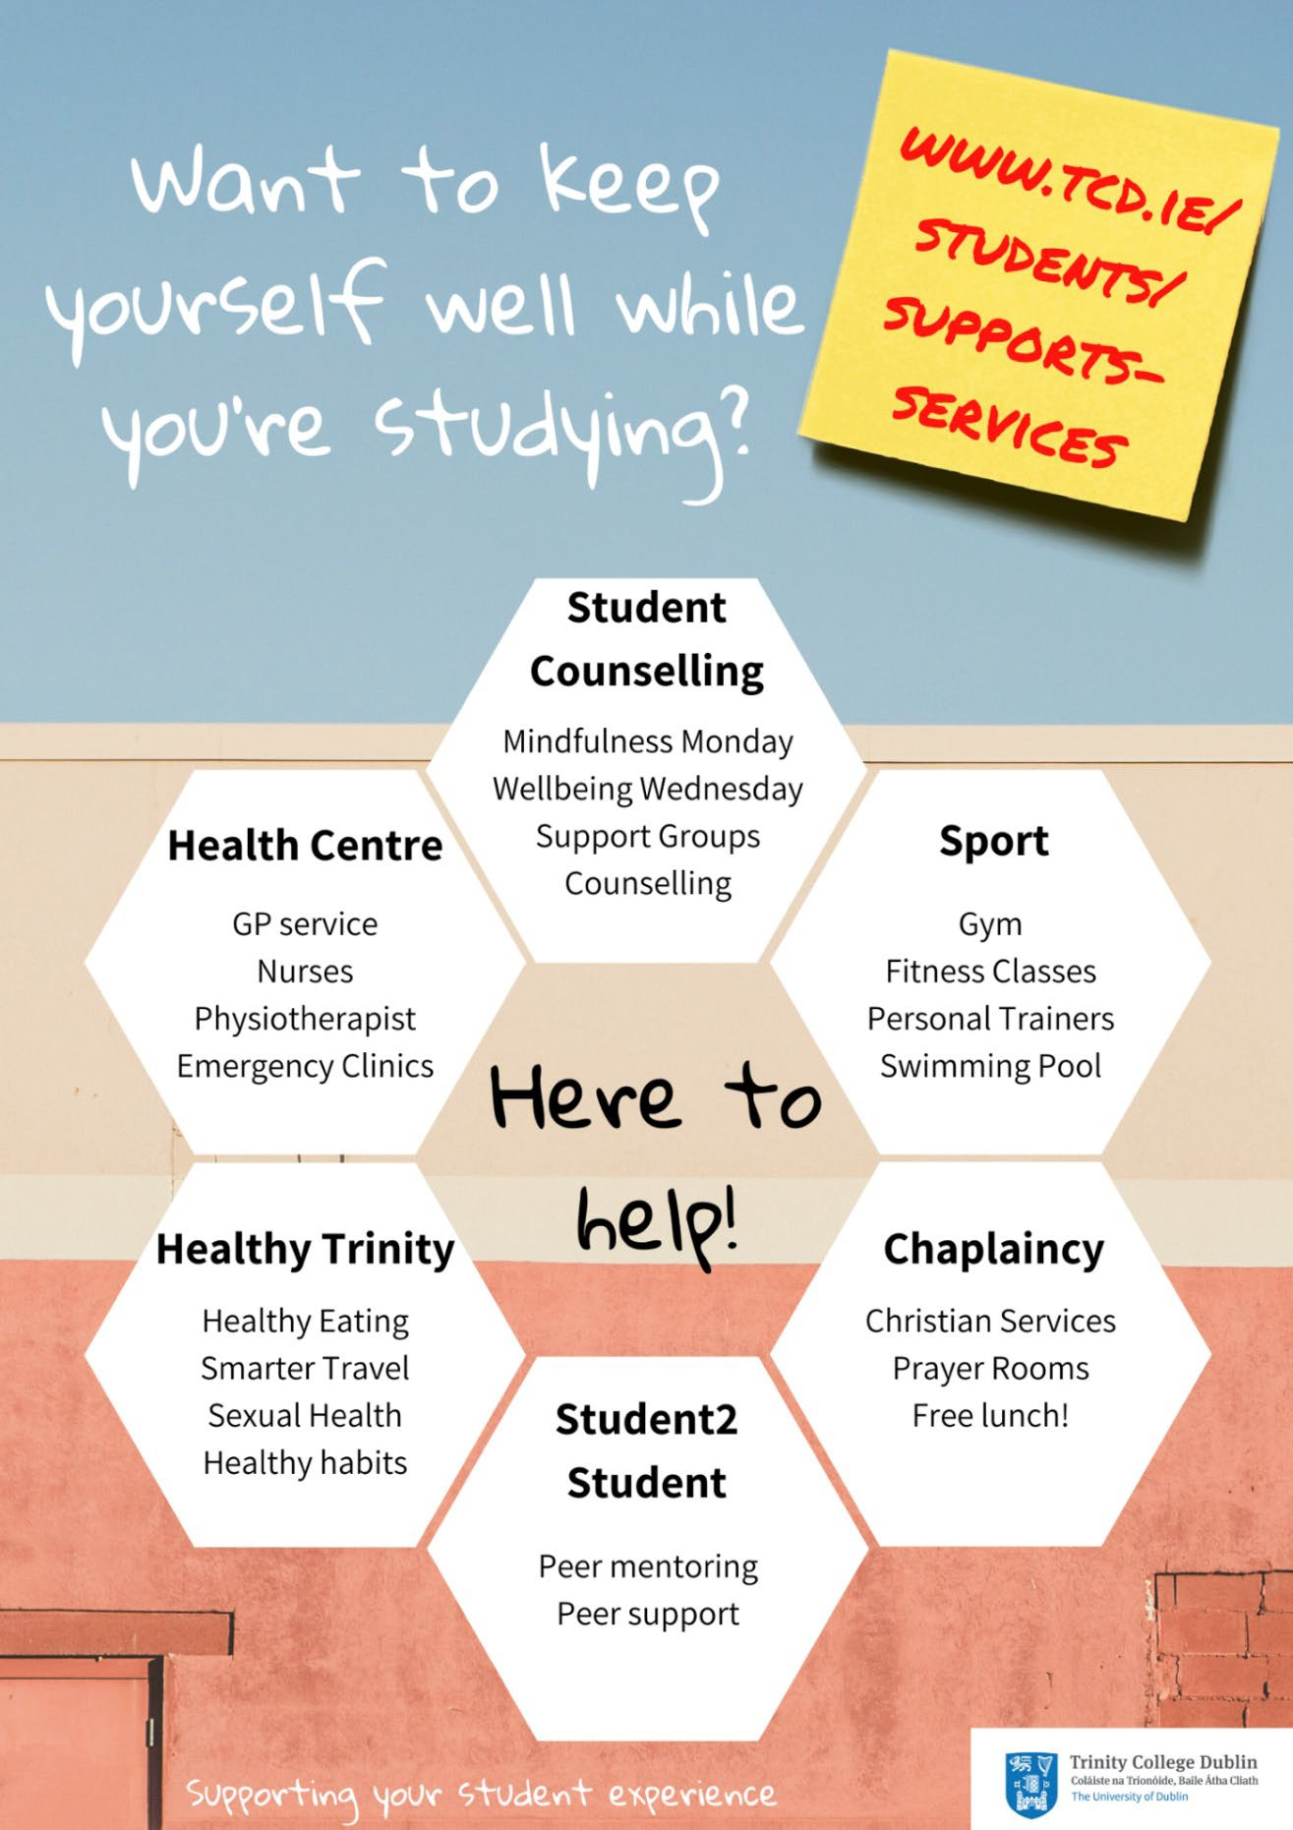

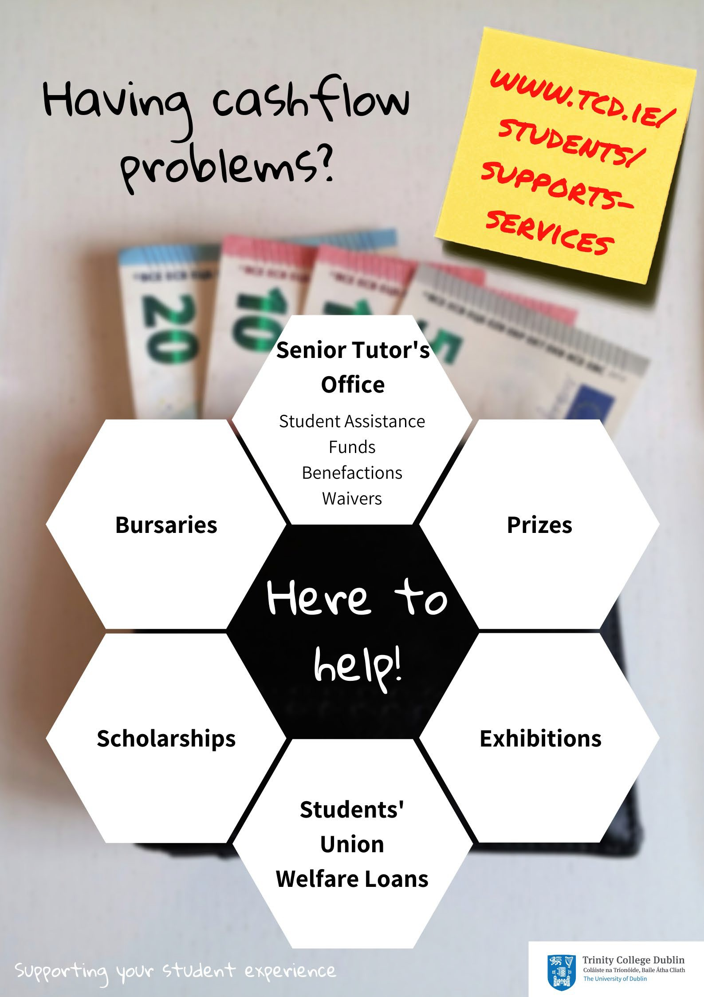

Student Learning Development | http://student-learning.tcd.ie/
The Library | http://www.tcd.ie/library/
Maths Help Room | http://maths.tcd.ie/outreach/helproom/
Undergraduate Programming Centre | http://www.scss.tcd.ie/misc/psc/
Language Learning Centre | http://www.tcd.ie/slscs/clcs/llc/
English for Academic Purposes | https://www.tcd.ie/slscs/english/
Disability Service | http://www.tcd.ie/disability/
Careers Service | http://www.tcd.ie/Careers/

  - Health and Wellbeing Support

Student Counselling | http://www.tcd.ie/Student_Counselling/
Health Centre | http://www.tcd.ie/collegehealth/
Sport | http://www.tcd.ie/Sport/
Healthy Trinity | http://www.tcd.ie/healthytrinity/
Student2Student | http://student2student.tcd.ie/
Chaplaincy | http://www.tcd.ie/Chaplaincy/

  - Getting Involved

Students’ Union | http://www.tcdsu.org/
Clubs | http://www.tcd.ie/Sport/student-sport/
Societies | http://trinitysocieties.ie/
Volunteering | http://www.tcd.ie/civicengagement/
Entrepreneurship/Tangent | http://www.tcd.ie/tangent/
Global Room | http://www.tcd.ie/study/international/trinity- life/global-room/

Senior Tutor’s Office* | http://www.tcd.ie/seniortutor/students/undergradua te/financial-assistance/
Students’ Union Welfare Loans | http://www.tcdsu.org/welfare/
Bursaries/Prizes (Undergraduate) | http://www.tcd.ie/calendar/undergraduate-studies/ (Part D: 11 - Prizes and other awards)
Bursaries/Prizes (Postgraduate) | https://www.tcd.ie/calendar/graduate-studies- higher-degrees/  (Section XI: Postgraduate Awards and Travel Funds)
Exhibitions | http://www.tcd.ie/calendar/undergraduate-studies/ (Part D: 8 - Entrance Awards)
Scholarships | http://www.tcd.ie/study/undergraduate/scholarships  -funding/
*Remember, you can ask your Tutor for advice and guidance about anything and they will point you in the right direction

Administrative Support

Your Tutor | http://www.tcd.ie/seniortutor/
Postgraduate Advisory Service | http://www.tcd.ie/seniortutor/students/postgraduate
Academic Registry | http://www.tcd.ie/academicregistry/

  - Your Tutor
All registered full-degree undergraduate students are allocated a Tutor when starting in College. Your Tutor is a member of academic staff who is appointed to look after the general welfare and development of all students in their care.

You should see your Tutor whenever you have a question or are worried or concerned about any aspect of College life or your personal life, in particular if it is affecting your academic work. Everything you say to your Tutor is in strict confidence. Unless you give them permission to do so, they will not give any information to anybody else, whether inside College or outside (not to your parents/family for example). Your Tutor can help you only if they know you are facing difficulties, so if you are worried about anything go and see your Tutor before things get out of hand. Whilst your Tutor may not be able to solve the underlying problem, they can help you find the best way to limit the impact of your situation on your College work. Tutors can help with academic advice, changing course, withdrawing from College, exam regulations, financial assistance and personal advice.

Postgraduate Advisory Service
The Postgraduate Advisory Service offers free, independent, and confidential support, guidance and advocacy to registered postgraduate students. They are here to provide support on any matter that may impact upon your time as a postgraduate at Trinity.
Some of the most common issues students come to PAS to discuss include: study-related stress or worry; concerns about academic progress; supervisor-relationship concerns; extensions and going off-books; queries regarding regulations and academic appeals; bullying; plagiarism and disciplinary cases, financial assistance.

The Academic Registry
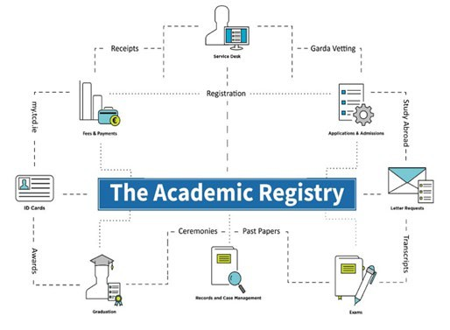

  - Information on key campus locations
You may include information on key campus locations relevant to your School’s students. Click or tap here to enter text.

Reference/Source

Student Supports & Services

Interactive College Map

  - Student Representation and Governance
Information on the TCDSU student representation structures are available at the following links:

TCDSU

TCDSU Student Representation Overview

  - Careers Information
Information on Careers for your students Click or tap here to enter text.

References/Sources:

Trinity Careers Service

Careers - PG Focus

- ACADEMIC WRITING

  - Academic Integrity and Referencing Guide
Standard Text to be copied from the Calendar with a link to the Academic Integrity Policy (currently in development) included.
A link to the Library Guidelines on Academic Integrity and a link to the declaration text for submitted assignments.
Should there be local policy on referencing or programme copy of the coversheet declaration, relevant links and/or details to inform students.
Click or tap here to enter text.

References/Sources:

Calendar Part II, Part B: General Regulations

Calendar Part III, Section 1: General Academic Regulations

Statement of Principles on Integrity

Academic Integrity Policy (currently in development)

Library Guides – Academic Integrity

Coversheet Declaration

  - Research Ethics
On relevant programmes, Schools should provide relevant links and information regarding good practice in research, as well as provide information on College and Faculty policies and procedures.
Click or tap here to enter text.

Research Ethics

Policy on Good Research Practice

Ethics Policy

- GENERAL INFORMATION
  - Emergency Procedure
In the event of an emergency, dial Security Services on Extension 1999

Security Services provide a 24-hour service to the College community, 365 days a year. They are the liaison to the Fire, Garda and Ambulance services and all staff and students are advised to always telephone Extension 1999 (+353 1 896 1999) in case of an emergency.
Should you require any emergency or rescue services on campus, you must contact Security Services. This includes chemical spills, personal injury or first aid assistance.

It is recommended that all students save at least one emergency contact in their phone under ICE (In Case of Emergency).
It is also recommended that students download the SafeZone app to access alerts for closures in inclement weather, etc.

Health and Safety Statements
Applicable information relating to health and safety in the classroom, laboratories, or other locations as relevant
Click or tap here to enter text.

Data Protection
Information on Data Protection regarding your student data is available from:

Data Protection for Student Data

  - Explanation of ECTS Weighting
The European Credit Transfer and Accumulation System (ECTS) is an academic credit system based on the estimated student workload required to achieve the objectives of a module or programme of study. It is designed to enable academic recognition for periods of study, to facilitate student mobility and credit accumulation and transfer. The ECTS is the recommended credit system for higher education in Ireland and across the European Higher Education Area.
The ECTS weighting for a module is a measure of the student input or workload required for that module, based on factors such as the number of contact hours, the number and length of written or verbally presented assessment exercises, class preparation and private study time, laboratory classes, examinations, clinical attendance, professional training placements, and so on as appropriate. There is no intrinsic relationship between the credit volume of a module and its level of difficulty.
The European norm for full-time study over one academic year is 60 credits. Within Undergraduate courses 1 credit represents 20-25 hours estimated student input, so a 10-credit

module will be designed to require 200-250 hours of student input including class contact time, assessments and examinations. Within Postgraduate courses, 1 credit represents 25 hours estimated student input, so a 10-credit module will be designed to require 200-250 hours of student input including class contact time, assessments and examinations.
ECTS credits are awarded to a student only upon successful completion of the programme year. Progression from one year to the next is determined by the programme regulations. Students who fail a year of their programme will not obtain credit for that year even if they have passed certain component. Exceptions to this rule are one-year and part-year visiting students, who are awarded credit for individual modules successfully completed.
Reference/Source:

Description of ECTS for use in Course Handbooks

Links to Further University Policies and Procedures
The following are links of where to find further information on University regulations, policies, and procedures that you may find useful as a student:

All Academic Policies

Student Complaints Procedure

Dignity & Respect Policy

Equality Policy

