|  |
| --- |
| Assistive technology Outreach Programme University College Cork |
|  |
|  |

# Andrew Costello – Assistive Technology officer Trinity College Dublin

|  |
| --- |
|  |

# Introduction:

This case study intends to evaluate an outreach project run by the University College Cork (UCC) in the academic year 2012 – 2013. The project centres on the use and promotion of assistive technology software and hardware. This review also intends to evaluate the opinions of Dublin HEI’s (Higher educational institutions) to implement a similar outreach role individually as an institution or via a shared HEA approach.

The term Assistive technology can be described as any use of technology which helps you perform a task more easily. A more structured definition of assistive technology can be provided by Cook and Hussey (2008) as any piece of equipment or product system whether acquired commercially off the shelf, modified, or customized that is used to increase, maintain or improve functional capabilities of individual with disabilities. Assistive technology devices covers a broad spectrum of hardware and software from low-tech devices such as a simple walking cane or magnifying glass to more sophisticated high-tech devices such as screen reading software or voice recognition software with an aim to support and enhance life’s of disabled users.

In delivering a successful assistive technology support service a range of challenges arise in the selection, trialling, expectation setting and successful use of such devices. Research in this area has shown a high level of abandonment of assists technology devices without adequate support and correct matching of the technology at the initial assessment phase. Marcia Scherer a leading researcher in this field (2002) states. “.In spite of the increased variety and availability of AT, approximately 30% of obtained ATs are discarded within a year. While there are many positive as well as undesirable reasons for this rate of discard, a major reason is poor assessment of consumer needs and preferences. “

Many frameworks exist within this area that highlight the main attributes/factors a user has obtained in order to avoid this abandonment. An example of such a framework is Cook and Hussey (2008) Human, activity assistive technology model (HAAT). As Cook & Hussystates “The HATT model is proposed as a framework for understanding the place of assistive technology in the lives of persons with disabilities”. It highlights the importance to consider such factors as the human characteristics/skills, activity, assistive technology underlined by the context in which the technology will be used.

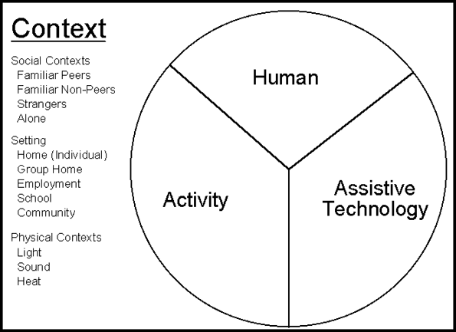

Figure HAAT model Cook & Hussy

As the above diagram OF HAAT model (vd.edu) shows the context also known as the milieu or the environment in which identifies how the technology is used underpins how a successful adaptation of such technology needs to be supported by outside factors and support channels. Such an approach of identifying support channels and understanding is at the heart of the UCC outreach project.

From communication with UCC’s outreach AT officer Deirdre Madden the UCC project main objective was to raise awareness of assistive technology for perspective incoming students looking to study a third level in UCC. The project aimed to build links with UCC’s catchment area of secondary level schools, visiting teachers and parents to promote the of assistive technology at secondary level and at home. In raising awareness and building relationships it is hoped that students will have greater awareness and engagement with technology in an educational environment and build confidence in its use when going to study at third level. It is also an aim that such a project will lead to greater use and empowerment for the student in employment environment. Such objectives can be seen to fit with the HATT framework in promoting/supporting the use of assistive technology.

Figure 2 Aims of the UCC assistive Technology Outreach Project

# Background information on the project need:

The background to the development of such a project comes in response to a government objective set by two national initiatives to increase the number of students with a disability attending third level education. The disability access route to education (DARE) and Association for higher education access and disability (AHEAD) are both working examples of such initiatives. The DARE programme gives students at secondary level and access route into third level at reduced CAO points. Participating colleges ring fence and number of places on specific courses at reduced points. On presenting specific medical evidence showing a need for additional support the student is accepted onto the scheme.

The recent 2012 DARE annual report (Dare.ie) have highlighted the limitations of the DARE scheme without the necessary pre-entry support:

Effectiveness of the scheme

* Limited effectiveness of DARE with regard to students with physical, sensory and multiple disabilities which is related to previous attainment levels at second level.
* Greater outreach activities can successfully counter long-term barriers to HE.
* DARE has had the unintended consequence of being aligned to a ‘medical model’ rather than a ‘social model’.
* Limited uptake of supports provided by Disability Services is a source of tension across HEIs.
* Only 40% of DARE eligible entrants accessed supports provided by Disability Services.

The Ahead scheme (ahead.ie) main focus is promoting supports networks currently available at third level. This government funded initiative run a number of promotion events and literature to encourage students to avail of the access schemes & to continue with their education. The ahead scheme runs in tandem with the Dare scheme, this initiative promotes good practice in making available the right information at secondary level to schools and parents and prospective students. Ahead works with all third level universities and institutions to provide access to improve the transition rates amongst leaving cert students.

With the above schemes in mind UCC identified the need to engage in outreach initiatives to improve participation of all disability cohorts and promote their supports services and resources if they opted to choose UCC via the CAO application process. The UCC AT outreach project aimed specifically at students in the Cork region catchment area to raise awareness and understanding of how technology can improve ability and make a transition to third less daunting step for students with disability. With this aim the service set about the implementation of an outreach project that could meet this need.

A further question coming out of this case study and from research into other pockets of good practice throughout Ireland was if there is a need of a shared HEI approach to outreach assistive technology activities to encompass the entire island. The Reach report (2011) looked at this question to evaluate the level of AT outreach services currently provided by HEI’s in Ireland. The report highlights a clear miss balance of such initiatives around east coast of the country.



**Figure 3:** Counties Receiving Outreach AT Service from HEIs

From such feedback and from the project set out by UCC project this report also raises the question of a need of a shared approach from Dublin HEI’s. As the referenced the above figure shows there is a lack of any assistive technology outreach programs provided by any Dublin HEI in assistive technology the most populated part of the country. As part of this report, each HEI was asked to contribute to an online survey to gain feedback on the need or future plans to engage in a similar assistive technology outreach programme akin to the UCC case.

# Case study specifics and design:

Central to achieving the aim of this outreach project at the initiation phase a requirement was to recruit a specific outreach assistive Technology officer. Previously to the start of this project UCC had one dedicated Assistive Technology officer – Linda Doran. From interviewing Linda and researching the specific roles for the project Linda explained her workload is based in the support of high needs 3rd level students in the use of Assistive Technology in UCC. The time and resources needed for the project to be a success needed “to be full time and had resources to build a trust relationship” as Linda commented. As further human resources were identified the employment of Deirdre Madden was completed in the early summer of 2012. The core objective & as commented on previously was to build a working knowledge of the benefits of Assistive Technology amongst a range parties involve d in 2nd level education as shown in figure 4 below.

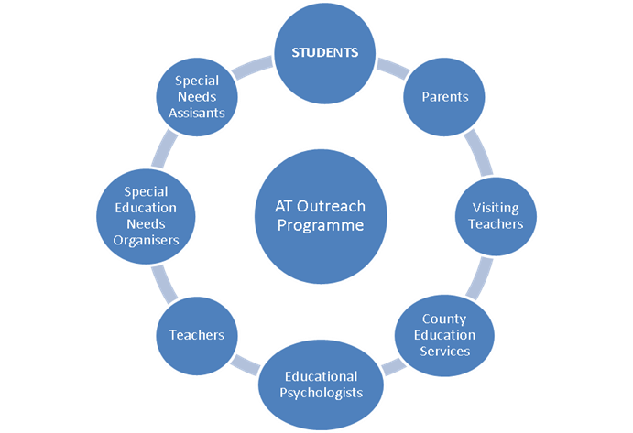

Figure 4 Stakeholders in the field of education and disability with whom the AT Outreach

With the advent of government educational cutbacks at all levels engagement wit he above areas highlighted the need of how technology can play a key role in replacing/aiding support such as the SNA support teacher. From interviewing Deirdre on her experiences she commented “ schools and parent are looking for viable cost effective alternatives to supporting student with a variety of disabilities, our project give an easier introduction on how basic and free technology support can help make the gap in supports easier to manage”

The design of the project was structured to engage users using two main streams –

**1. Outreach assistive technology support school and local meetings giving an overview of a range of technologies and its benefits:**

Broad spectrums of regional based secondary schools were contacted via email, printed leaflet s and phone. The College also used existing contacts via the college’s access + scheme that previously have worked with a range of disadvantaged secondary and Deis schools (disadvantaged schools areas pinpoint by the department of education). A total of nine outreach introductory talks were given between the date of September 2012 and April 2013, held in a variety of locations from school halls to local community based hotels. In total 177 people attended these events ranging from a variety of stakeholders outlined in figure 4 above. The basis of these meetings were informal, broad and aimed to give a high level view of assistive technologies available to a spectrum of disability cohorts. The aim was not to cover specific Assistive technology issues related to one specific disability type but to generate interest and understanding of how technology can enhance the learning environment for the student. At the end of each session all participants were invited to specific training sessions covering nine disability cohorts where users and students could trial and demo presented on assistive technologies that could possibly meet their need. Attendees were also asked to invite any possible school staff members or parents/students to the specific training sessions. The outreach schools and local meetings act as promotional tools to get more people involved in the programme.

**2. In-house UCC specific/ requested school training sessions**

In total 73 training event were rolled out on a weekly basis. The majority of the sessions were held with UCC and aimed to showcase specific assistive technologies that attendees could test, trial and ask question about their benefits. The project also accommodated training sessions held with individual schools of which 47 secondary & primary schools engaged. The sessions each lasting three hours covered 9 areas of educational assistive technologies:

* Blind and visually impaired (Jaws & Kurzweil software)
* Deaf/HOH ( Radio aids / Loop systems use / Digi – systems)
* Physical disabilities ( mobility aids \ voice recognition software)
* Free accessibility features on PCs and iPad / Free available software
* Literacy support (including Read & Write Gold)
* Mind mapping (including Inspiration )

840 users attended the sessions ran over a 6 month basis. Users were not confined to attending once and were allowed to attend multiple session s. Deirdre Madden UCC outreach officer commented on this process that “we had more success running community-based sessions via getting engagement from secondary schools directly”. Engagement in secondary schools relied heavily on the use of additional agreed “Croke park” training hours which is problematic due to reluctance of some staff to engage in technology as a learning tool. From interviewing Linda Doran (UCC in-house assistive technology officer) she commented that “although no level of IT expertise is needed for session some teaching staff were sceptical in how such technology could be used within a classroom environment as they did not possess the necessary technology skills”.

The use of any formal assistive technology framework was also raised and if such a formal approach to such a roll out was needed to give a better argument to the need of Assistive technology within a classroom environment. From communication again with UCC on this matter no specific framework was introduced at either training session. It was felt that the sessions were to inform and introduce the benefits of assistive technology against carrying out assessments or making specific recommendations. As the project had no funding to procure any new pieces of equipment for schools or individuals. It was felt it would be unfair to pinpoint technologies that school or individual could not afford. The sessions allowed attendees see numerous assistive technologies in action and its benefits. The UCC based training sessions also fit focused heavily on freeware that schools and parents could easily download and use straight away. The approach as quoted by Linda Doran “small steps to build relationships and awareness of the technology.”

Results & outcomes from this outreach project (which will be discussed in detail later) are shown to be in line with other AT outreach studies in this area. Craddock and McCormack (2002) show how the benefit of assistive technology has grown where there is community-based support channel for users to rely on. This Irish-based research paper introduces the use of a technical liaison officer (TLO) as a support channel for users who have difficulty understanding the benefits of technology they have been recommended. A similar approach has been introduced by the UCC in providing community-based support channels for users to understand and engage in assistive technology.

A mirrored approach can also be seen in a project carried out by the Athlone Institute of technology Letterkenny Institute of technology (AIT.ie). A similar aim here is exist in improving awareness around the use of assistive technology and improved participant’s rates of students with disabilities in third level in the relevant institutions. The introduction of the try-it – [www.try-it.ie](http://www.try-it.ie) online resources is also an example of a resource looking to increase participation rates in assistive technology. This online resource gives free loans of commonly used such technology to educational based institutions. Rebecca Beck project manager of the try it.ie commented on this initiative “as an example of inter-agency collaboration and has already illustrated the positive impacts on services that can be achieved at the results of sharing resources have participating in non-disability specific multi- agency model of practice.” (Emiliani , Burzagli, et al 2009).

# Research methods:

The research methods used to evaluate and review this case study were divided into three main areas to ensure a clear subjective assessment of the case and to highlight areas of future work /factors that could prohibit such engagement in such a positive initiative. The design of the research took a mixed method approach correlating both quantitative and qualitative analysis of the case. The three methods used were:

1. **Interview**: UCC have two assistive technology officers involved in outreach activities - Linda Doran and Deirdre Madden. Linda, who supports high needs students with assistive technology solutions who are currently registered students with UCC. Linda agreed to give feedback on the objectives of the project, resources needed and the structure of the outreach sessions via a phone interview. Deirdre Madden UCC’s outreach AT officer was interviewed face-to-face at a recent HEI access to higher education conference. Deirdre was asked about the success of the programme to date, on the figures achieved and aims for the project moving into year two. Both interviewees were made aware of the intention to use the qualitative information gained from our conversations to feedback into this case studies report.
2. **Literature review**: a variety of literature was reviewed to support the valuation of the UCC outreach project. A number of academic research papers have completed similar studies in this area and a range of commonly used assistive technology framework assessment papers were introduced to give foundation for a need for such outreach work. In addition a number of in-house UCC disability service project reports completed by the outreach officer on reflection of year one of the project. Further to this a number of national subjects specific reports were reviewed to give reflection on the success and need for such further projects in the future.
3. **Survey**: to gain quantitative methods on the use and desire of Dublin-based HEI’s to engage in future collaboration on a similar based project an10 question online survey was sent to 16 disability support staff working in third level disability student services. A direct mail was sent to each head of service and assistive technology officer within that institution asking them to assess and contribute on the UCC assistive technology initiative and if they felt it was a need for such a roll out within the Dublin HEI area.

# Results & Monitoring:

Year 1 UCC AT Outreach results**:**

In evaluating the project‘s outreach officer Deirdre Madden relied heavily on qualitative data. On the completion of each in-house training session each participant was asked to complete a set questionnaire. This questionnaire was also sent out to all participating schools in total over 300 users who had engaged in the project. From communication with Deirdre Madden the overall feedback was positive although it was noted getting responses from users was difficult and hard to monitor effectively.

The year one review report (UCC AT report year 1 2013) produced by UCC indicated that 90% of the attendees that the session was effective and useful. From the online questionnaires sent out to schools below charts give overview of some of the key results showing a positive outcome coming from the programme:

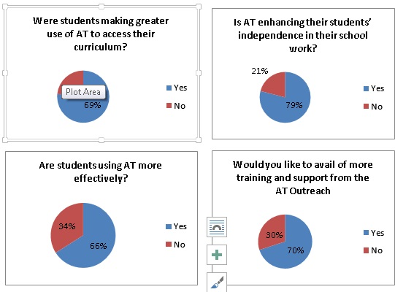

Additional qualitative quotes provided by participants showing how the such a project has been achieved in improving knowledge of assistive technology and confidence in its use:

**Student:** “It really boosted my confidence and there should be more programmes like thisaround.”

**Parents:** “Today was the first day that she ever heard anything positive about dyslexiaand it reaffirmed her ambition to go to UCC. “

**Teachers:** “I found the training very informative and relaxed which broke down a lot ofthe barriers I hold towards technology and the nervousness concerning the useof in my classroom.”

### Dublin HEI online survey results

The below results show key results to questions asked of Dublin-based HEI’s in the need for a shared third level approach to assistive technology outreach work. A survey also aimed to gather interest and the level of resources available to HEI’s in their commitment to future collaboration. In total seven 3rd level institutions were invited to participate in the survey with each institution assistive technology officer and support staff targeted.

From a possible 17 responses 10 were received showing the below key results from the nine questions asked:

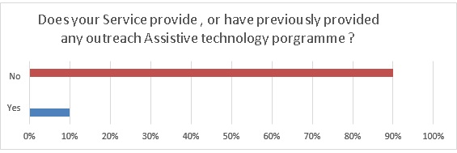

* Comment on this question centred on the engagement of college’s access programs and early learning initiatives.

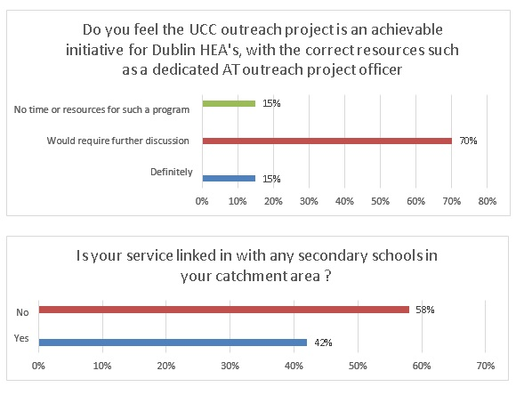

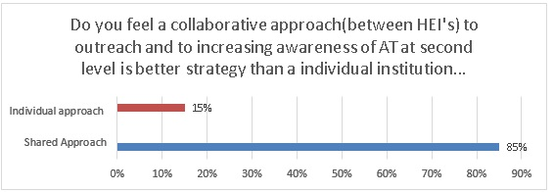

* Comments on these questions centred around the need & agreement for a shared approach due to lack of resources and potential better return on investment.

# Analysis & reflection

In analysing this case study and similar Irish based research within this area it is clear that any outreach technology based supports are advantageous for the schools/parents in gaining a better understanding of assistive technology supports and expectations of education in third level environment. Providing such initiatives also help build lasting relationships between secondary levels to third level education and grows transitional links that enhances the student’s ability to reach their full potential.

The positive feedback and results from the qualitative data received from the online feedback forms from the training attendees show how if structured and resourced correctly how assistive technology can increase confidence in the use these tools at secondary level and can provide skills for students with disabilities to transition into third level. The use of assistive technology can also provide parents/ schools with cheap and free tools to enhance the learning environment for all students in doing so creating a universal approach to learning. The technology can also provide solutions for students who have difficulty engaging in the traditional read/write method of learning allowing them to adjust how they learning style to a method that suits them e.g. text to voice – visual learning. The data results reflects the objective of the project clearly been met and gives a good working examples for similar HEI’s to adapt.

It is important to note such initiatives are not without difficulties. 30% of the HEI’s found they did not have the time or current resources to replicate such an initiative. They need time and adequate human resources to ensure project objectives can be achieved. From surveying Dublin base HEI a clear pattern was ascertained for the need for a shared approach. 85% responders agreed such an approach could be worth pursuing in promoting the use of assistive technology. This would ensure that HEI’s would work together and building links to secondary level and will not work in competition for such a venture. The HEI survey also highlights that there has been no assistive technology outreach programs provided in the Dublin area. This is in line with the reach report’s findings, which also confirms that there have been no such initiatives within eastern based counties.

In addition to engaging with secondary level schools the project also endeavour to get buy in from disability support organisations such as national Council for the Blind in Ireland (NCBI) and relative deaf associations. Such engagement from support organisations would be beneficial as they have an existing support network in place for students with a sensory disability. UCC’S commented on the large numbers of students requesting support information from the project regarding a specific learning difficulty (SpLD) against the underrepresented student numbers with a sensory difficulty. However UCC reported such communication was poor to establish with outside agencies with lack of time resources available to these organisations again contributing to the lack of engagement. Such avenues are needed to be explored again to encompass such valuable support networks already established within Ireland.

Drawbacks of such grouped open approach to outreach can inevitably lead further questions on support of such technologies within a classroom environment. For example, who is going to pay for such devices or software and how to set expectations from parents on the outcomes of engaging in such technologies? The UCC outreach project approach was to introduce free assistive technology solutions available from the web or within the try it.ie loan scheme. The project shows there is no need for substantial funding to be made available more importantly it needs basic buy-in from within the schools and support from parents in encouraging use of such technologies. Using such technologies to replace human base support such as exam readers or scribes could improve the integration and acceptance of such enabling devices.

The project also gives good working examples of how to overcome basic technophobia amongst end-users. Although no level of technology expertise is needed in using assistive technology the reluctance to engage in new approaches to study is a difficult challenge to overcome, especially amongst teachers. A reluctance to take on a new unfamiliar approach can restrict and slow down acceptance of such technologies. The need of constant support cycle from such outreach programs is vital for a reassuring the end user in the use of the technology and promote positive outcomes.

Conclusions

The purpose of this project was to raise awareness of assistive technology for disabled students, parents and teachers to engage in. The awareness would lead to greater fulfilment in the students’ academic journey lead to greater progression into third level with the use of technology as an helpful aid in achieving this goal. The project highlights the lack of existing knowledge of assistive technology within secondary level schools. The evidence from this case study review shows there is an appetite for knowledge amongst parents and students in availing of technology supports that is simple and free to use. The end-user is simply lacking a support channel in the selection and use of such software and devices. The study has gone some way towards enhancing our understanding of barriers that can inhibit successful integration of assists technology within a secondary level.

Further work is needed on ensuring assistive technology is core within a learning environment that adequate resources are available to support such devices and technologies for teachers and parents. Only such support structures can enable successful use of assistive devices and extinguish the abandonment of such enabling supports. This case study has only examined a small sample of users on a project ran with a particular focus on assistive technology. A further study could incorporate information held by specific disability organisations and by college access programs who have soldiered existing relationships with underrepresented disability cohorts under use non-use of assistive technology supports they have had access to avail of.

Overall this case review has given an account a successful outreach programme in year one of its setup. It shows how assistive technology can be a benefit to post student an institution in improving student and transition phases between secondary in third level.

# References

Cook, A., Hussey, S., 2001. Pg,5 Assistive Technologies: Principles and Practice (2nd Edition). Mosby.

Scherer, M.J., Sax, C., Vanbiervliet, A., Cushman, L.A., Scherer, J.V., 2005. Predictors of assistive technology use: The importance of personal and psychosocial factors. Disability & Rehabilitation 27, 1321–1331.

Cook, A., Hussey, S., 2008. Pg36, Assistive Technologies: Principles and Practice (3rd Edition). Mosby

Ahead - Association for Higher Education Access & Disability [WWW Document], n.d. URL http://www.ahead.ie/ (accessed 6.11.13).

DARE > Disability Access Route to Education [WWW Document], n.d. URL http://www.accesscollege.ie/dare/index.php (accessed 6.11.13).

Reach > http://studentresourceait.org/wordpress/wp-content/uploads/2013/07/Reach-Report.pdf, n.d.,pg.6 (accessed 8.11.13)

Craddock, G., McCormack, L., 2002. Delivering an AT service: a client-focused, social and participatory service delivery model in assistive technology in Ireland. Disability & Rehabilitation 24, 160–170

AIT.ie > [WWW Document], http://www.ait.ie/disability/reach/ (accessed 8.11.13)

Try.it.ie >[WWW Document], http://www.try-it.ie/Welcome.do;jsessionid=409DF64FB4EA8AE3C7EE472D99C3DBD0 )accessed 08.11.13)

Emiliani, P.L., Burzagli, L., Como, A., Gabbanini, F., Salminen, A.-L., 2009. Assistive Technology from Adapted Equipment to Inclusive Environments: AAATE 2009. IOS Press

Wessels, R., Dijcks, B., Soede, M., Gelderblom, G.J., De Witte, L., 2003. Non-use of provided assistive technology devices, a literature overview. Technology and Disability 15, 231–238.

Online Survey >[WWW Document], https://www.surveymonkey.com/s/F76SVV8

# Table of Figures

1. Assistive Technologies in Agriculture - Home - Virginia Cooperative Extension [WWW Document], n.d. URL http://pubs.ext.vt.edu/442/442-084/442-084.html (accessed 11.6.13).

2. http://www.ucc.ie/en/media/support/disabilitysupportservice/at/Endofyear1report.pdf (accessed 13.6.13)

3. Reach > http://studentresourceait.org/wordpress/wp-content/uploads/2013/07/Reach-Report.pdf, n.d, pg 6 (accessed 13.6.13).

4. http://www.ucc.ie/en/media/support/disabilitysupportservice/at/Endofyear1report.pdf (accessed 13.6.13)

# Appendicies

Dublin HEI’s. Participating in the online survey:

UCD – University College Dublin

TCD – Trinity College Dublin

NUIM - National University of Ireland, Maynooth

DIT – Dublin Institute of Technology

DCU - Dublin City University

IADT - Dún Laoghaire Institute of Art, Design and Technology

NCAD - National College of Art and Design