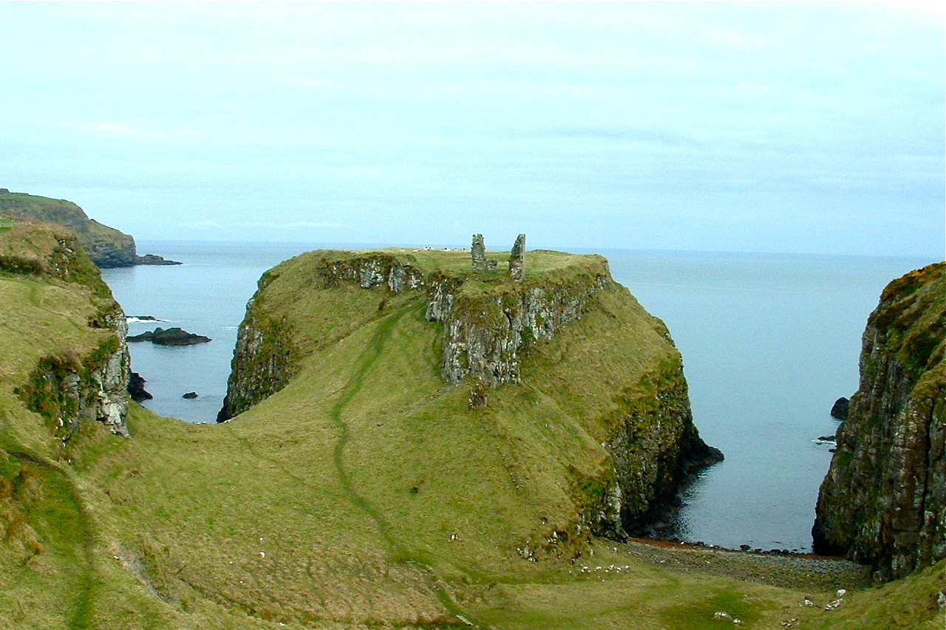
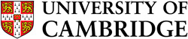

Junctions and Crossroads

We are pleased to announce that this year’s keynote speaker will be Dr. Barbara Crawford, OBE, Honorary Reader at the University of St Andrews

Cambridge Colloquium in Anglo-Saxon, Norse and Celtic

25th February 2012

Dr. Crawford will be speaking on ‘The Joint Earldoms of Caithness and Orkney’

The Department of Anglo-Saxon, Norse and Celtic at the University of Cambridge invites proposals from postgraduate students for its annual interdisciplinary conference.

Papers should take no longer than 20 minutes to deliver. Please submit a 250-word abstract of your paper by 19th December 2011 to ccasnc@gmail.com

