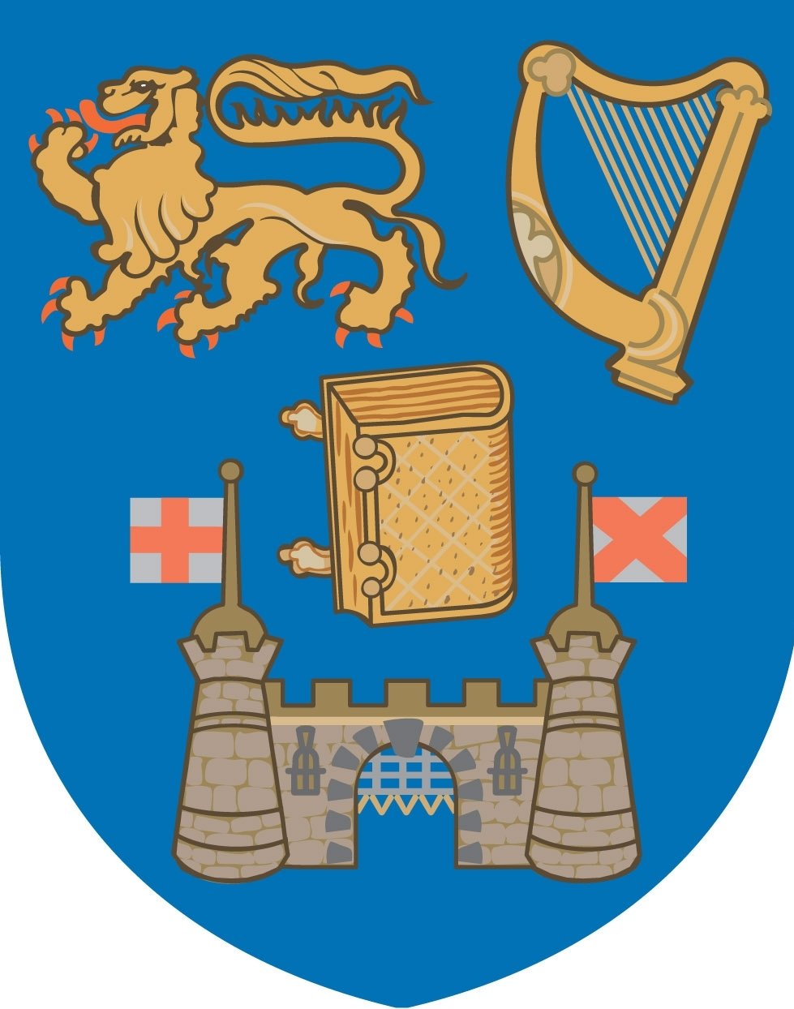 | COLÁISTE NA TRÍONÓIDE, BAILE ÁTHA CLIATH  OLLSCOIL ÁTHA CLIATH  TRINITY COLLEGE DUBLIN  THE UNIVERSITY OF DUBLIN

THIS IS A EXAMPLE OF STATIONERY WHICH COMPLIES WITH THE
OFFICIAL LANGUAGES ACT REGULATIONS
EFFECTIVE FROM MARCH 1ST 2009-

NOTE IRISH FIRST IN HEADER AND FOOTER

PLEASE CONTACT COMMUNICATIONS OFFICE IN RELATION TO ALL COLLEGE STATIONERY REQUESTS

ALL DEPARTMENT/SCHOOL TITLES TO APPEAR IN IRISH FIRST

Coláiste na Tríonóide, Faiche an Choláiste, Baile Átha Cliath 2, Éire.
Trinity College Dublin, College Green, Dublin 2, Ireland.
T: 01 8961000 F: 01 6710037 www.tcd.ie

