**Estates & Facilities**

**Annual Report 2016 – 2017**

**Our Mission statement is “Protecting our Heritage and providing for our future”. We deliver our services to the community day and night. 24/7/365.**

On a day to day basis we provide the facilities operational services of a medium sized town. Based on our population Trinity is the equivalent of a town such as Athlone, but with one significant difference. Athlone has multiple owner occupiers who have responsibility for the operation and upkeep of their individual premises. In Trinity there is one single department that has responsibility to open gates, make sure the lights and heat come on, clean and maintain the buildings, take away the rubbish, cut the grass and look after security, plan and construct new buildings.

**Extent of Estate**

The University’s estate occupies a total of 305,000 sq.m. The buildings are situated on some 101 Acres / 41 Ha over 7 different sites around the city.

* City Centre Campus (Including Westland Square, Biosciences, Westland Row/Fenian Street, Goldsmith Hall, Foster Place/Anglesea Street, D’Olier Street and Sth. Leinster St, Stack B, & Clare Street)
* Trinity Technology and Enterprise Campus
* Trinity Hall, Dartry
* St James’s Hospital
* Tallaght Hospital
* Santry Sports Facilities
* Islandbridge

**Buildings**



Our buildings range in ages from 6 years old to over 300 years.

**60%** of our buildings are over 100 years old.  
**25%** of our buildings are over 200 years old.

**Key Statistics**



**People**

* 390 Staff across the Directorate.

**Budget**

* €25m Capital Expenditure in 2016/17
* Operational Expenditure of €29m

**Significant Achievements during 2016/17**

* Restructured Directorate with

Premises Manager led Service - We have established a clear legible structure for customers with identifiable persons responsible for coordinating the delivery for designated areas of the university.

Shared Support Services across Estates & Facilities.   The Shared Services Model introduces a single Service Centre for all the activities of the entire Directorate, together with Accounts and General Admin groups serving all E&F functions.

* On line locker system introduced.
* Supporting increased commercial activity such as the Summer Concert Series.
* MV project, planned and well advanced, increasing electrical capacity for increased activity and future developments
* Printing House Square project to provide student beds and student services started on site
* Organ Refurbished off site and returned to Public Theatre for installation.
* Nominations Agreement concluded for 750 student residences in third party developments to enable TD Global to offer guaranteed accommodation to international students.
* Continuing work on Backlog Maintenance. 11 separate Projects completed + We have carried out a range of upgrading and refurbishment projects across the university
* Estates and Facilities Service Centre launched on 12th December, 2016 - The opening of the Service Centre at 194 Pearse Stand the introduction of the Premises Managers were both parts of our overall restructuring exercise and assist in our objective to deliver a customer focussed service.
* New Estates and Facilities iSupplier catalogue launched February 2017 resulting in a more streamlined and timely income generation process
* Workflow process mapping for key Accounts Unit and Service Centre functions completed.

**Operations and Maintenance**

**Cleaning**

Premises Services provides 4170 hours of cleaning each week to the university, ensuring an attractive working environment for all.



**Maintenance**

Our maintenance teams carry out an average of 400 maintenance operations every week.



**Guest Services**

In summer we provided services to support 52,000 visitor bed nights (Trinity is the biggest hotel in Dublin) , helping to secure valuable commercial income for the university.

 

**Lockers**

A new On-line locker booking system was introduced. 2500 lockers are available for booking online.

*This initiative means that queuing for lockers and for deposit return has now been eliminated for students.*



This is an example of an improvement in our service that came about from fresh thinking about how the service might be delivered.  New management in this area brought new thinking.   Modern technology allows us to provide an on line facility which is quicker, more efficient and more customer friendly.

**Shared Support Services**

A key aim of the Estates & Facilities restructuring was to provide an integrated seamless service and to improve efficiency.  It involved the amalgamation of 5 separate units, each with its own admin support.    
Administrative functions have now been centralised into one shared services team with the following focuses; Accounts, General Admin and a Service Centre providing support for all E&F functions, customer engagement and communications.

|  |  |  |
| --- | --- | --- |
| **Shared Administrative Support Services** | | |
| **Customer Service Team** | **Accounts Team** | **Admin Services Team** |
| Front facing team of the Service Centre.  Managing the Service Centre Desk, customer engagement and communications | Supporting all areas of the Directorate with the management, reporting and processing of area budgets and financial transactions | Provides a shared administrative support function to the Directorate in areas such as insurance, capital projects, health and safety, staff records, time & Attendance, Campus and Premises Services. |

* Enhanced entrances and visitor facilities will improve the Visitor experience
* Major Tourist attraction. “one of the most beautiful campuses in the world” (Forbes magazine)
* New MV power installation completed, securing existing supply and facilitating future growth
* 2,500 lockers available online, increasing capacity and facilitating easy access for students.
* Premises Services provides 4170 hours of cleaning each week to enhance the working environment and supporting 52,000 tourist bednights in summer
* increased our use of renewable energy by 2% per annum, in line with our policy to reduce carbon emissions.
* Landscaping improvement projects improve the campus for Students, Staff and visitors

**Infrastructural Development**

**Supporting Strategic Planning**  
With an eye to a 50-year future, Estates and Facilities is actively supporting Trinity in developing an estates strategy for the University, which will prepare the ground for a major master plan for the campus, including establishing needs and standards and setting a framework for sustainable capital infrastructure development.

**New Buildings**

We have **23,610 sq.m** of space under construction with planning under way for a further **120,000 sq.m.,** representing an **expansion of 32%** in the area of Trinity Buildings within the next decade.



*This will provide additional academic space for expansion in teaching and research and additional residential spaces for students and for summer commercial activity.*

**MV Project**

The Campus Medium Voltage Upgrade project will increase the overall electrical supply capacity by 20% (From 7.5 MVA to 9 MVA). The supply is delivered by ESB Networks via a new cable to a new single main electrical intake substation in Pearse Street.

The project includes the complete replacement of the ageing and vulnerable existing medium voltage distribution infrastructure across the University, providing a more secure and resilient supply to the Campus.

*This project secures the existing power supply and will enable new projects under construction, such as the Business School and Printing House Square, and provide capacity for future teaching and research projects.*

**Emergency Planning**

Two table top exercises carried to assist in preparedness for possible emergencies.

**Health & Safety**

As part of the role of supporting workplace safety wealth and welfare the Safety Office has been involved in supporting academic and commercial activities, and successfully rolled-out Labcup – a cloud based chemical inventory system.

* Staff Training in H&S continued.
* 95 courses delivered to a total of 1172 people in 16/17

**Insurance**

Estates and Facilities manages the insurance portfolio for the university which involves 16 different types of insurance policy.

For the first time, Clinical Trials Insurance has been procured for 2017/18. This will help generate research funding.

December 2016 saw the launch of a new online travel insurance application web ap. 1560 applications were processed in the first 9 months.

We are continuing to work with colleagues to develop a single overall College policy on student placement in order to reduce the insurance and reputational risks.

**Campus and Landscaping**

Estates and Facilities is very proud that Trinity College Dublin has been rated by many publications, including Forbes magazine, as “one of the most beautiful campuses in the world”. The university is widely respected for its policy of commissioning architecture from some of the best architects.

In 16/17 the Campus Planting Programme was initiated, aimed at extending and improving planted areas across the campus. The planting at the House 40 entrance to College Park has been very successful and further areas have been identified for such projects.

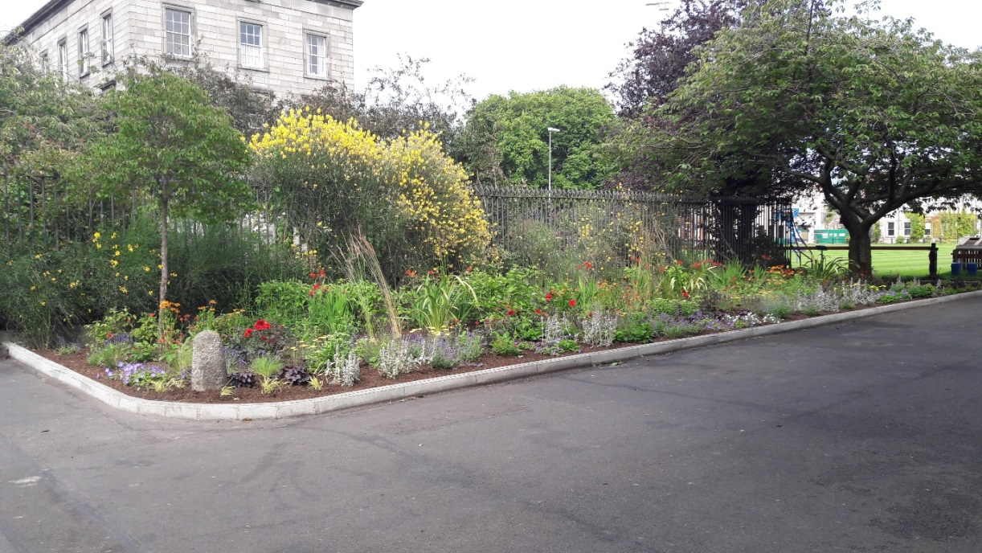

Other improvements to the landscape have been achieved by the removal some street furniture from historic areas of the campus and by increasing grounds maintenance staffing levels at peak times and at weekends.

*The quality of our external spaces and the ongoing Landscaping improvements add to the enjoyment of our campus for students, staff and visitors. They enhance the reputation of the university and help to recruit students, staff and attract visitors.*

**Energy / Utilities Consumption**

* Trinity is a significant user of electricity and Gas, some 35m kWh electricity and 34m kWh of natural gas are consumed annually.
* We used 255m litres of water, equivalent to 390 swimming pools, last year.

In support of university Sustainability policy there is an increasing focus on reducing utility consumption

Trinity has improved its energy efficiency by 21% against the 2006-08 baseline. – In a like for like comparison, this would equate to a reduction of 3000 Tonnes of Carbon / CO2 (if University energy efficiency improvements and national grid improvements had not taken place)

* We are working towards a target reduction of 33% from 2008 to 2020.
* A number of projects across the campus involving high efficiency LED lamp replacement have contributed to date such as Stack B fit out, 4th Fl. South Leinster St and Grd. Fl. Lloyd Building.
* All new developments are being designed to Near Zero Energy Building (NZEB) standard in advance of regulation.
* we increased our use of renewable energy by 2% per annum,

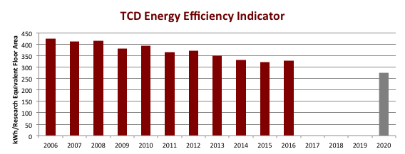

*Trinity’s achievements in energy consumption are steps towards its strategic goal to minimise its carbon footprint and to establish itself as an exemplar sustainable university. In 2018 we will become part the International Sustainable Colleges Network.*

**Waste Management**

Camus Services waste management team deals with 40 T of waste / week.   
As part of Trinity’s commitment to Sustainability weare recycling 50% of our waste.

**Estates and Facilities Website**

The Estates and Facilities website was launched on 12th December, 2016. Since then we have recorded:

|  |  |
| --- | --- |
| **311,828** | Hits to the website since it’s launch |
| **1,876** | Unique website visitors per month *Average |

**Summary**

Throughout the year we have worked to meet increasing demand for our services from a university that is expanding all the time. We have worked with the university community and our colleagues in Commercial Revenue Unit to support events ranging from the Trinity Ball to Summer Concert Series and making motion pictures. We will continue to do that going forward.

We have introduced initiatives to improve the appearance of the campus.

We have a new website, with a new Service Centre in 194 Pearse Street as a single point of contact for all our services. This has allowed us to improve and expand our service, bringing it to the community via our Service Desk and our Premises Managers as our primary points of contact, aiming to be the best we can be.

Through our restructuring we have delivered a new operating model based on service level agreements, designed to protect the university from operational risks, to enhance customer experience, to introduce greater flexibility in service delivery and minimise energy use.    
Premises Managers were appointed in July 2016 so 16/17 was the first year of their operation in the new structure.  
Premises teams have been established, bringing together over 300 front line staff who previously worked in either the Buildings Office, Housekeeping, or Attendant Services to form Premises Teams with new reporting structures.

We have led the development of a number of significant capital projects and supported planning for future projects and for the university’s estates masterplan.

**In 2017 /18 we will:**

* Progress additional residences at Trinity Hall Dartry
* Commence design on E3 Learning Foundry
* Undertake the Arts Building Refresh project
* Undertake the first stage of the Library / Trinity Visitor Experience
* Continue to look for ways to increase the stock of student accommodation.
* Work to advance further development projects such as TTEC, Cancer Institute, and we will develop recently acquired Sports Facilities at Iveagh Grounds Crumlin.
* Implement the first phase of our Integrated Workplace Management System
* Continue and expand our electrical vehicle and equipment trials.
* Continue our tests aimed at replacing and increasing bicycle parking facilities
* Revert to Board for approval of updated policies on after-hours access to buildings and lone working, supported by comprehensive guidance documentation.
* Support Sustainability policy and progress Trinity’s aim to be the first Irish member of the International Sustainable Colleges Network ( ISCN)

*Through these activities we will provide additional and better facilities for our community, enhance the visitor experience and contribute towards commercial activity and income. We will enhance further Trinity’s reputation as a beautiful campus that will attract the highest quality staff and students and increased numbers of visitors. We will develop Trinity as an exemplar member of the International Sustainable Colleges Network.*