Tuesday 14TH December 2010

The Department of Hispanic Studies, Trinity College Dublin, in association with the Instituto Cervantes, Dublin, are organizing an evening with the award-winning author Jimmy Burns, who will talk about his latest publication Papa Spy (2009).

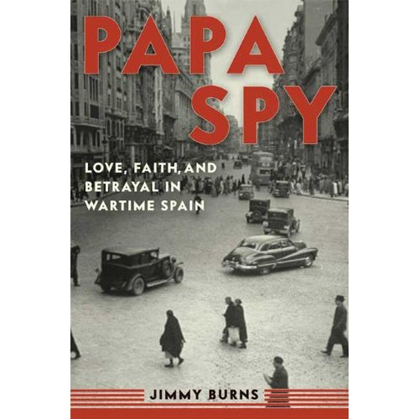

The book, set against the background of international diplomacy and espionage during the Second World War, recounts the activities of Tom Burns, who in 1940 was appointed Press Attaché to the British ambassador in Madrid, Sir Samuel Hoare. To protect Gibraltar from Hitler, Churchill’s brief to Hoare had been to weaken German influence in Spain and to prevent Franco entering the war on the Axis side.
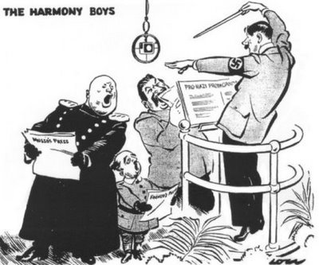
David Low, 2nd May 1940

Burns, unaware of the machinations of Kim Philby and associates and the suspicions of certain members of the British establishment about his Catholicism and his conservatism, organised an effective propaganda campaign as well as an underground espionage network that covered Spain, Portugal, and North Africa. This is his story, a fascinating behind-the-scenes tale.

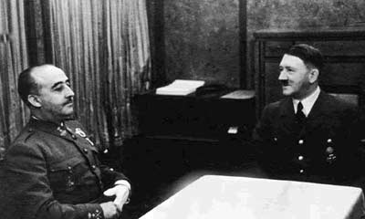

Franco and Hitler at Hendaye, 23 October 1940

INSTITUTO CERVANTES
Lincoln Place, Dublin 2
Event starts at 6 o’clock

