Public Investment in R+D –

a Sense of Perspective

**Patrick Cunningham, chief scientific adviser to the Irish government (2007-2012)**

Systematic investment of public funds in research and development is a relatively recent feature of human society. The demands of military technology in two world wars have been an important driver, with the message being driven home by the atomic bomb. In addition, it is generally recognized that advances in health, wealth and general well-being in society are largely based on advances in science and technology.

In recent decades, most governments have included a line item for R+D in their annual budgets. However, there is a very widespread lack of appreciation of several aspects of this expenditure. The public, including politicians, often have little sense of the scale of expenditure relative to other items. The purposes are often unclear. And the balance and interaction with private business investment is

very variable across countries, and indeed across sectors of the economy.

Broad Perspective

The OECD annually assembles the data on investment in R&D, both public and private, from its 34 members and 7 other countries. Their totals can be taken to represent the global picture, because in most other countries expenditure on research is generally low. The global figures, together with those for the EU and the US are shown in Figure 1.

Figure 1 Public and Private Investment in R+D ($bn) 

The EU and the US between them make up more than half of both private and public investment globally. In both areas, as well as elsewhere, public funding makes up about one third of the total.

Global expenditure on R+D has stabilized in recent years at about 2.4% of GDP. In the decade to 2007, it had grown steadily, though slowly, as a percent of GDP. In the recession years since then, many countries have in fact reduced their investment – of 19 OECD countries reporting data, 12 have reduced their public science budgets since 2007.

Patterns of expenditure

The most notable difference in the purposes to which public R&D expenditure is directed is to be found in a comparison of the EU and US. Some 57% of the US Government R+D budget goes for defense, as against 5% in the EU. The EU civil R+D expenditure thus amounts to $107bn compared to $62bn in the US. Another notable difference between the two areas is that in the US most public funding comes through the federal budget, while in the EU over 90% comes from 28 different national budgets.

The point is often made that investment in defence technology has had spin-off benefits for the private sector also (see for example Mazzucato, 2013). Together with the concentration of US public funding in large federal programs, this undoubtedly gives large American businesses an advantage over their European competitors, who face an array of much more dispersed public funding programs.

For civil (i.e. non-defense) public R+D expenditure, the OECD collect three classes of data, on (1)economic development in sectors such as industry, agriculture, energy (2) health, environment, education, social and space research, and (3) non-oriented and general university funds. It would be reasonable to have expected a shift in favour of economic development in the recession years since 2007. However, the OECD data do not show such a trend.

Most countries invested between 20% and 30% of their science budget in economic development objectives in 2012. However, only one, Ireland, had increased that figure by more than 10% in the years since 2007. And while the Irish state science budget for economic objectives went up by 13%, parallel business investment also increased, by 43% in the same period.

Figure 2. Percent of Government expenditure for R+D declared to be for economic development, 2012.

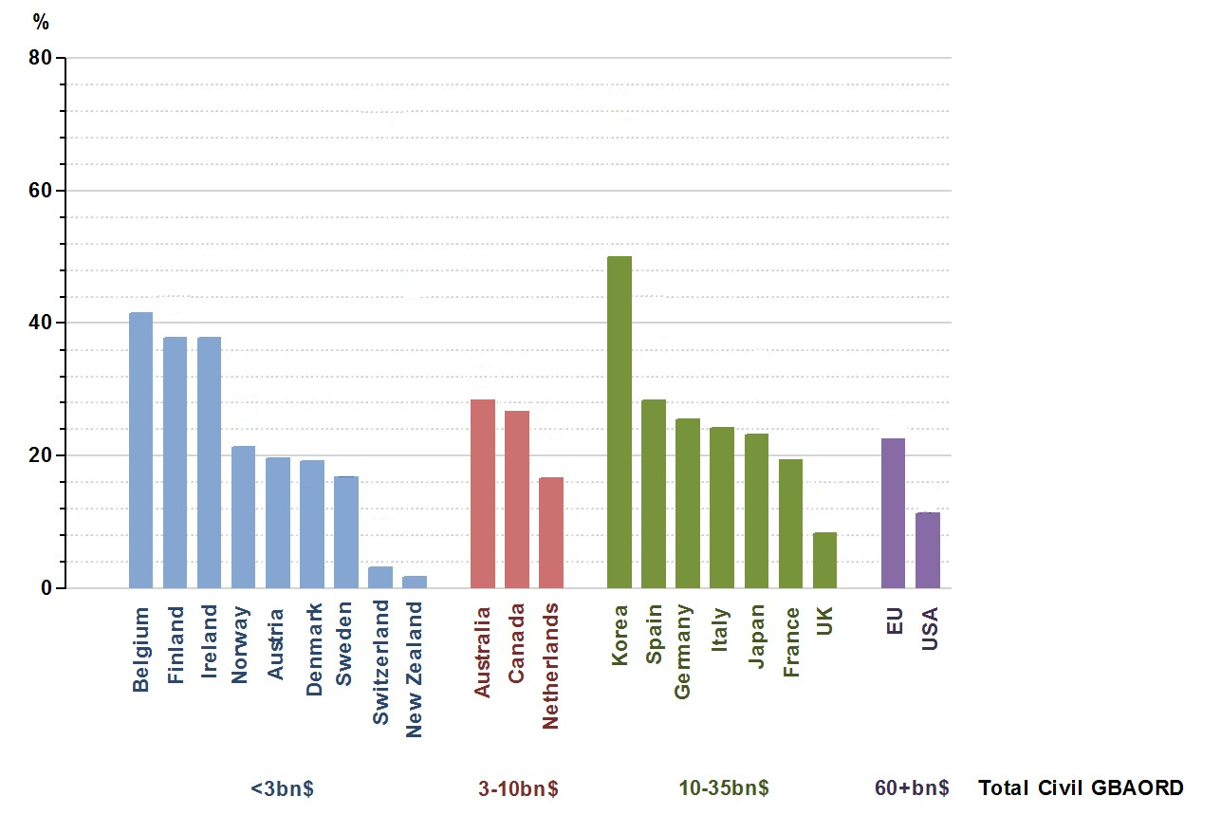

The pattern of public R+D budgets for economic objectives is shown in Figure 2 for all countries reporting. Among the smaller countries (under $3bn),

Belgium, Ireland and Finland allocated some 40% to economic aims, with most others at about 20%. The larger countries also generally had a figure of about 20%, with two notable exceptions: Korea at 50% and UK at 10%. Finally, the EU as a whole had twice the US figure: 20% versus 10%. Further analysis of these differences(and similarities) could be informative.

The ambition of the EU 2000 Lisbon strategy to spend 3% of GDP by 2010 on public and private R+D has been achieved by only three countries, Denmark, Sweden and Finland. For the EU as a whole, it is still under 2%. Public R+D investment at 0.7% is still well below the Lisbon target of 1%.

With over 90% of public R+D expenditure still locked in the national systems, the European Union is a form of rolling experiment in the deployment of public funds to drive societal advance. Given the scale and importance of future societal needs, and the proven benefits derived from previous investments in R+D,

There is a strong argument for increased analysis of investment and return.

Public Perceptions

In most developed countries, the annual state budget amounts to more than 50% of annual GDP.

Typically, up to three quarters of this budget is taken up to provide social protection, health and general public services. In general these represent spending to meet today’s needs. The remaining quarter is capital investment to meet future needs: improved infrastructure, education of the rising generation, and funding of research and associated development. Figure 3 shows the recent pattern of these investments for Ireland. At 1%, R+D is the smallest slice of all of this public expenditure. Together with education, it is the most important for long term societal progress.

Figure 3. Distribution of total government expenditure, Ireland, 2010.

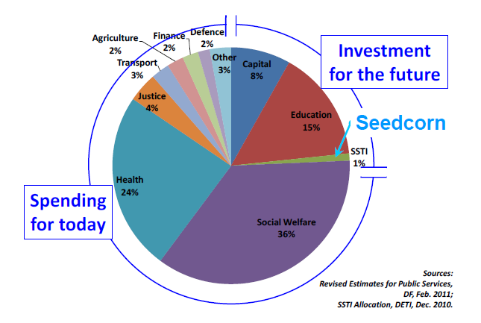

The challenge for policy makers, and particularly for politicians, whose horizons are necessarily focussed on the next election, is to protect investment for the future against the demands of the present.

References

Cunningham, Patrick.(2013) Set research priorities in a time of recession. Nature, 502,433/4

Mazzucato,M. *The Enterpreneurial State (Anthem, 2013)*