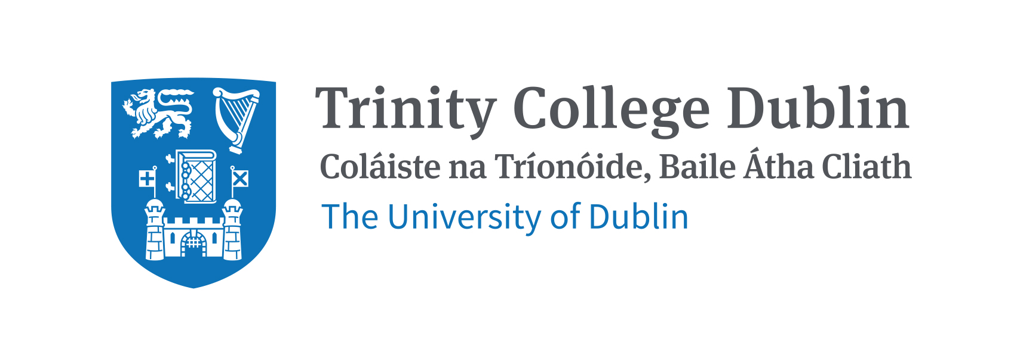

Application Form
Trinity College Staff Peace Pilgrimage
to Israel and Palestine 2017.

c.18th – 25th June 2017

Name(s):

Address:

Contact phone number

Email

Position in College

Age _______ Have you travelled to the Holy Land before? Y / N

Please use the space provided to write a brief paragraph as to why you are keen to explore the Holy Land, with particular emphasis on why you wish to participate by hearing from different experiential voices living with conflict in a contested space.

While there is no application process to join the experience, spaces will be limited. Hence, please return your form by
1st December 2016.

Please return form to
Rev Dr Julian Hamilton julian.hamilton@tcd.ie

Once a form is accepted you will be invited to book your place by sending a non-returnable deposit of €50

