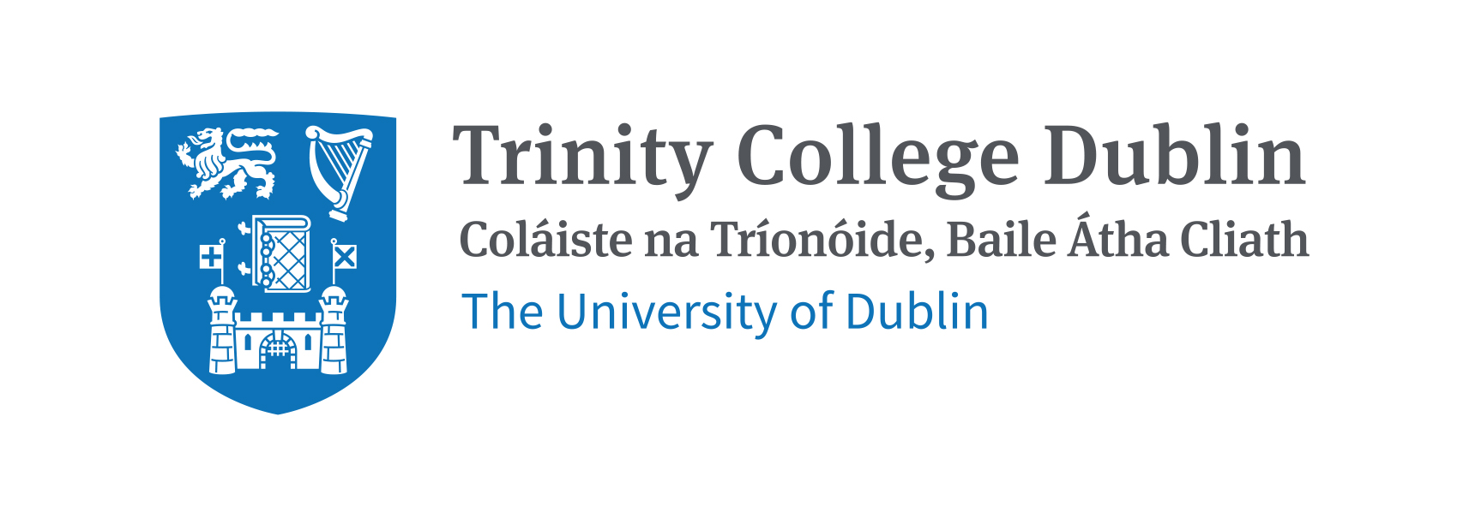

Application Form
Conversations That Matter
Corrymeela 2017.

c.10th – 12th Feb 2017

Name:

Address:

Contact phone number:

Email:

Course of Study:

Age _______ Have you been on a CtM residential before? Y / N

Please use the space provided to write a brief paragraph as to why you are keen to explore the ‘Conversations That Matter Residentials’ … with particular emphasis on some of the themes you imagine you would like to engage with while on the residential.

While there is no application process to join the experience, spaces will be limited. Hence, please return your form by
30th January 2017.

Please return form to
Rev Dr Julian Hamilton julian.hamilton@tcd.ie

It is hoped that the residential will be heavily subsidised – leaving you c. 30 euros to pay. You will be informed closer to the time of exact prices, but it will not be expensive.

